Executive summary
  - Aims of the programme
The Care Council was selected to deliver a national resources and learning programme to support implementation of the Social Services and Well-being (Wales) Act 2014 (the Act). The programme ran from 2015 to 2017, over two financial years. The resources and learning programme had two overarching aims and objectives, to:
- Ensure the workforce can deliver social services in accordance with Welsh law and its interface with other relevant statutes; and
- Ensure the workforce can deliver care and support in keeping with the principles, culture and values outlined in the Act (voice and control for citizens, prevention and early intervention, promoting well-being, co-production, and working in partnership).
The focus of the programme’s activity in 2016-17 differed from 2015-16, where the activity focussed on the development of learning materials, and the early stages of training provision. In 2016-17, the programme focussed on rolling out core training to the workforce, and developing and delivering more specific and specialised learning materials to respond to the learning needs of the workforce.
The evaluation of the 2016-17 programme is informed by 71 qualitative interviews with a range of individuals affected by the Act, survey responses from 240 individuals who completed training modules, analysis of programme information and statistics and a literature review of similar projects.
  - Provision
In order to achieve these aims, the Care Council supported a wide range of activity in 2016/17 and seven key strands are covered in this evaluation. These are:
- The Hub: a bilingual website developed by the Care Council. It is a web-based ‘one stop shop’ where all key resources relating to the Act are available and freely accessible. The use of the website increased following the launch of the website in 2015, and peaked (at over 800 page views per day) in early and mid-2016, when the Act was introduced and a large volume of training was taking place. In the second half of 2016, the use of the Hub decreased slightly, but was still averaging over 500 page views per day.
- Awareness raising training materials: a set of materials developed by the Care Council and local authority training leads to provide an introduction and overview of the Act. A total of nearly 900 workers attended awareness raising training in 2016-17; a decrease from 2015-16 due to the number of workers who had already undertaken awareness training (7,000 reported in 2015-16) and the provision of alternative materials which provided more detail..
- Core training modules: materials aimed at workers most affected by the new legislation in terms of their responsibilities for assessment, safeguarding and looked after children. The five core modules were:
  - Introduction and general functions;
  - Assessing and meeting needs;
  - Safeguarding;
  - Looked after and accommodated children; and
  - Assessing and meeting the needs of people in the secure estate
presents the number of core training modules completed by workers in the sector. In total, nearly 12,000 core training modules were completed in 2016-17. The majority of modules were completed by individuals employed by local authorities.
There has been variation in the use of core training modules by region and sector. Some local authorities have struggled to engage with the health, independent and voluntary sectors, whereas others have had a much higher proportion of core modules completed by health and independent sector workers.
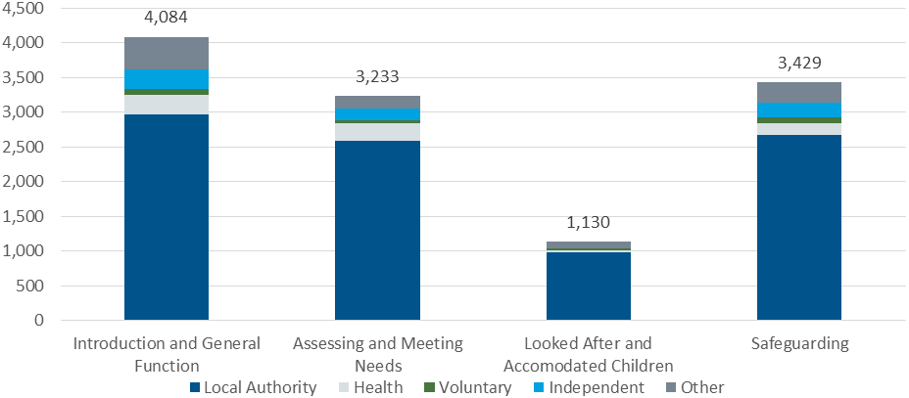
Number of core modules completed, 2016-17
Source: Social Care Workforce Development Programme (SCWDP) returns
- Leadership and management training: targeted at senior staff responsible for establishing and participating in regional partnership boards; aimed at increasing their understanding of their changing responsibilities and the changes required for regional partnership boards following the introduction of the Act. Only three regions provided the number of individuals who had attended leadership and management training - a total of 184 individuals.
- Expert classes: Either half or one day events which provided more detailed information on specific topics relating to the Act. These topic areas were:
  - Working with deafblind people;
  - Child care law;
  - Working with carers;
  - Advocacy;
  - Direct payments;
  - Commissioning; and
  - Co-production.
A total of 750 individuals attended the expert classes. The child care law expert class was the most frequently attended.
- Learning materials for the independent sector: materials developed in response to a recommendation in the interim evaluation titled “train for change”. These learning materials drew on the core training modules, but aimed to provide bespoke learning targeted at the independent sector. A total of 570 workers across four regions attended e train for change events.
- Training for authorised officers and legal officers working on adult protection and support orders: Training targeted at authorised officers which provided information on the newly introduced Adult Protection and Support Orders (APSOs). A total of 53 staff attended the training.
  - Quality
Overall, the learning materials developed and the training delivered by the programme is viewed to be of high quality.
The Hub has been a valuable resource for people to access information and learning materials relating to the Act. The resources on the Hub are reported to be of high quality and useful. The centralisation of information in one place has made it easy for people to find all the information they need. Knowing that the resources have been produced for all users in Wales has reassured people about their reliability and completeness.
All types of core module training session have been generally well-received, increasing participants’ confidence in their readiness to deliver a service in line with the Act. Case studies provided useful information about the practical implications of the Act and session content was reported by nearly all respondents to be relevant to their roles. Facilitators were generally good, although in some cases did not allow sufficient time for discussion or know enough about particular practice areas to be able to answer all attendees’ questions.
“I have made a lot of use of their learning resources. I’ve found them extremely useful and the information is easily available”
Leadership and management workshop participants reported having a general level of awareness of the requirements placed on Partnership Boards (in terms of its membership and priorities) prior to attending, but agreed that the workshops had provided a stimulus for implementing a response to these requirements. Workshops were well facilitated and the facilitator knowledgeable.
The feedback from the expert class participants shows that there was a high level of satisfaction with their quality and relevance.
The learners attending the “train for change” sessions expressed satisfaction with the content, with 84% reporting they were “very satisfied” with the session. They also reported that the sessions were well structured, with the facilitators knowledgeable about the Act and its implications for attendees. Some participants responded that it was difficult to cover all information effectively within one day. .
“I think it was very helpful… there were some really good examples and case studies that were used, and some techniques that people could take away with them and then use in their own areas. And it was a good opportunity to meet with colleagues, and hear how they were getting on, and that they were… having the same dilemmas and issues about it.”
  - Impact
Following completion of the core training modules, the average score for workers having the skills to deliver services in line with the principles of the Act increased from 5.5 to 7.4. The average score for workers having the skills required to deliver services in line with the principles of the Act increased from 5.2 to 7.3 (see Figure ES1.2).
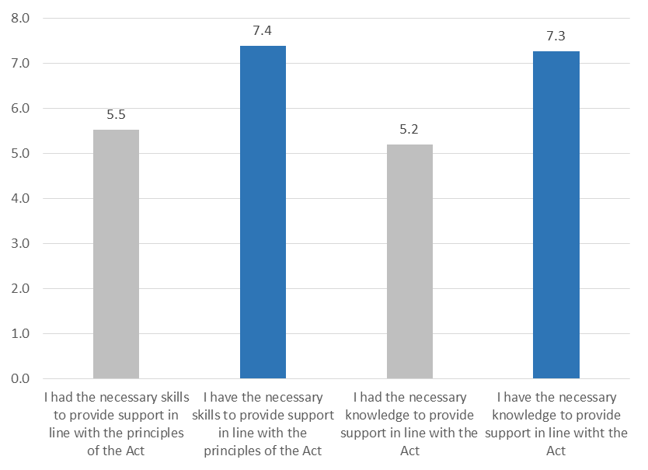
        - Please rate your level of knowledge on the following aspects of the Act, where 1 is no knowledge and 10 is a high degree of knowledge (before and after training)

Source: ICF survey of training participants, n=240
Almost all of the workforce, including frontline staff, report understanding the principles and ethos of the new Act, and the changes it is intended to deliver for individuals requiring care and support after attending the core training modules (see ES2).
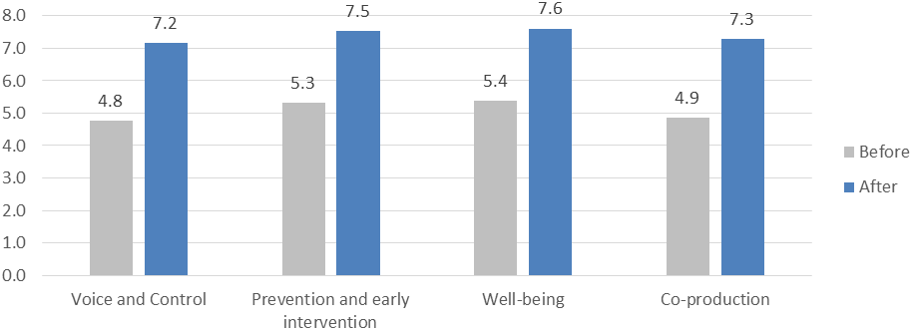
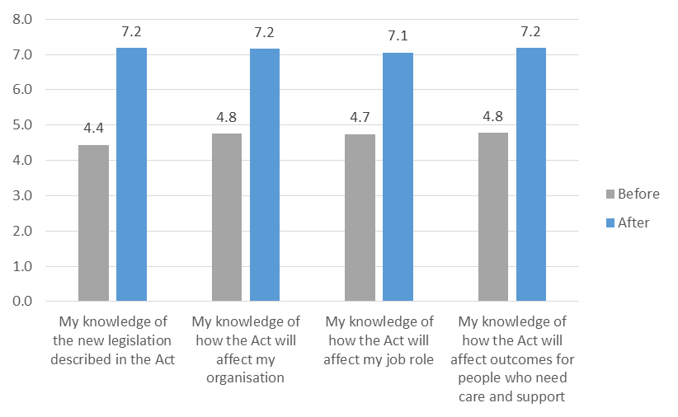
- Please rate your level of knowledge of the Act, where 1 is no knowledge and 10 is a high degree of knowledge (before and after training)
Source: ICF survey of training participants, n=240
However, progress in adapting organisational practices to bring them in line with the Act is mixed. Interview feedback suggests that about half of organisations have taken measures such as updating their documentation and induction practices, while others have yet to finish doing so. Organisations whose responses to the Act were less developed were generally those whose staff had attended training later in 2016, suggesting that during 2017 the proportion of organisations with updated practices will continue to increase. This indicates that the training has enabled organisations to take measures to prepare to deliver services in line with the Act, but they need time update practices.
The leadership and management workshops have stimulated Partnership Boards to update or create their strategy documents, and to begin recruiting greater numbers of representatives of the third sector and individuals requiring care and support.
  - Management of the project
The delivery model of the programme involved both the Care Council and regional and local authority training leads. The overall responsibility of the programme was with the Care Council. This included creating an internal programme board to oversee the programme and a Strategic Advisory Group to fully involve a wide range of partner organisations. Other partnership structures were created, including a virtual reference group to lead on training delivery, an Act training Group to lead on awareness raising, a number of reference groups and editorial boards to provide input into the training materials, and a trainers’ forum to provide support to trainers.
The local authority and regional training leads provided essential input into the development of the learning materials. They identified individuals who required training about the Act, ensuring sufficient training was provided in their area and promoted the learning materials.
The main strengths of the delivery model were:
- Speed: The Care Council responded to emerging training needs rapidly. The Care Council developed strong working relationships with the Welsh Government, regional training leads and specialist training providers to ensure learning materials were developed promptly.
- Consistency: The delivery model enabled the same learning materials to be developed once and used throughout Wales (with local tailoring). The materials were developed centrally, and all the trainers providing the core training were trained following the same materials.
- Scale: The pan Wales approach towards developing learning materials meant that the scope of the materials being provided could be larger. For example, developing the Hub would not have been possible if multiple organisations had developed their own materials.
- Flexibility: The Care Council stayed in regular contact with training managers and workers in the sector. When new learning needs were identified, the Care Council working with partners had the structures and resources to develop new learning materials to meet these needs.
- Detailed provision: The Care Council was able to spend some of the budget on developing learning materials on specialised topics, such as advocacy, working with carers, social enterprises, co-production and the provision for deaf-blind individuals.
- Reach: The combination of a national organisation and regional organisations being responsible for the programme helped with the reach of the programme.
The total value of the programme, excluding Care Council staff costs was approximately £823,000 in 2016-17. The largest areas of expenditure included: communicating and engaging with the sector, rolling out the provision of the core training modules and providing the expert classes.
The delivery model used by the Care Council provided value for money. All external procurement was conducted using open tenders, and where possible existing materials and in house expertise were used to develop learning materials. In the absence of the Care Council programme most employers (both local authority and independent sector) would have developed some training in response to the Act, but there was no consensus on what approach would be taken The Care Council programme reduced duplication of effort and reduced the level of expenditure in developing materials to train the workforce about the Act.
The average cost per unit of training is presented in Table ES2.1. Given the large increase in knowledge and skill and the large scale of course attendance, this indicates that the core training modules offered good value for money.
      - Unit cost of training activities
Type of training | Total spend (2015-17) | Number of participants | Unit cost (£)
Awareness raising | £20,000 | 7,962 | £3
Core training modules | £436,000 | 18,452 | £24
Train to change | £10,000 | 239 | £42
ICF calculations

  - Conclusions
Table ES2.1 sets out the key findings around the outputs generated by the Care Council’s work with its partners and the outcomes for individuals and employers of the use of the resource and learning programme.
      - Overview of findings
Key outputs and outcomes | Achievements | Challenges
Timely resources and training | - Producing learning materials to set timescales.  - Providing learning materials in logical order.  - Rapidly responding to emerging learning needs in the sector. | - Getting buy-in from all regions and local authorities to use and promote learning materials.
Relevant and accessible resources and training | - Materials provide comparable information throughout Wales.  - Materials tailored to meet local and sector needs.  - High levels of satisfaction with learning materials.
Capable trainers to deliver training | - Development of an approved trainer framework.  - Learners were satisfied with the level of knowledge and competence of their trainer. | - Some trainers underprepared in early stages of delivery.
Flexible materials for training and blended learning to reflect workforce needs | - Variety of learning materials (classroom based, e-learning, videos, information packs) provided.  - Materials tailored to meet local and sector needs
Resources widely used | - High levels of awareness and use of the Hub.  - Duration of page views on the Hub increasing.  - Nearly 12,000 core training modules completed.  - Leadership and management workshops, expert classes and train for change learning used throughout Wales. | - Variation in use of training by region and sector; some local authorities have struggled to engage with the health, independent and voluntary sectors.
Training taken up by all parts of the workforce/employers when needed | - Learning materials made available when needed by the sector. | - Variation in use of training by region and sector; some local authorities have struggled to engage with the health, independent and voluntary sectors.
Resources used for cascade training | - Evidence of managers disseminating findings from training to other staff. | - Individuals receiving direct training felt more knowledgeable about the Act than those receiving information from managers.
Workforce readiness and confidence to implement the Act’s requirements | - Increase in the confidence of the workforce that they have the skills and knowledge to deliver services in line with the Act. | - Where paperwork and practices have not been amended, frontline staff feel less confident in their readiness to deliver services in line with the Act.
Understanding by the workforce has increased, equipped to make changes | - Increase in the level of knowledge of the Act and how it affects workers organisations, job roles and individuals requiring care and support. | - Level of understanding varies by sector.
Understanding by managers has increased to implement changes | - Half of organisations have amended paperwork and induction processes. | - Where training was completed later in 2016, organisation less likely to have implemented changes.
Knowledge and skills applied in revised services | - Paperwork and practices altered in some organisations.

The key conclusions from the evaluation are:
- The delivery model for the programme was robust and most likely achieved more in a shorter time scale than an alternative approach such as providing a share of the same resources to local authorities.
- The working relationships established by the Care Council, Welsh Government and partners enabled the production of training materials to meet the programme timescales.
- Reaching out to all parts of the sector across Wales has not yet been achieved. In some areas, it has been challenging to engage with the health sector, despite additional funding being made available and a targeted advertising campaign. Where there has been success, this has been achieved through local approaches supplemented by additional national support by the Care Council.
- The programme has been successful in increasing the level of knowledge and skill in the workforce. More work is required to ensure that all sectors affected by the Act receive learning opportunities.
- The impact of the training and learning on organisational change is time lagged. Organisational change relating to changes in legislation is likely to be a long term process. More organisational change is expected in 2017, in organisations where workers attended training later in 2016.
- As learning activity is still on-going and the Hub remains a useful resource, the Care Council requires some funding for the 2017-18 financial year to respond to needs, for example additional communication skills training to provide staff with the skills to undertake the ‘what matters’ conversation with individuals requiring care and support and training on how the Act affects mental health services. Although funding is still required, the budget for the programme could be reduced from the current level of £1 million per annum.
“To date we are meeting what the requirements are but I think there will be more training needs to come. As the year goes on and the Act grows and people find out more information, I think people will realise that we are going to need training in other areas … it’s like anything else when it’s new, on paper, it sounds viable but when it’s put into action and in the real world, then issues arise.”
Team manager, private sector provider

http://www.ccwales.org.uk/the-act/
The number of workers attending core training on the secure estate has not been included in the figure. This is because of the low number of workers attending secure estate training. The SCWDP returns show that a total of just over 30 workers have attended this training module.
Workers in the sector could complete more than one core training module, for example three of the four training modules. The figure of 12,000 core training modules completed is a sum of the total number of individuals completing each of the five core training modules. Therefore the total does not represent the number of individuals who have completed all or some of the core module training.
North Wales, Gwent and Mid and West Wales.
Numbers attending in both 2015-16 and 2016-17
As data was not collected for all regions on participation in Train for Change training, this data is based on evaluation of the North Wales Train for Change programme, carried out by the Care Council (February, 2017)

