REGULATION AND INSPECTION OF SOCIAL CARE (WALES) ACT
TRAINING MODULE

How the Statement of Purpose supports the delivery of a good quality service
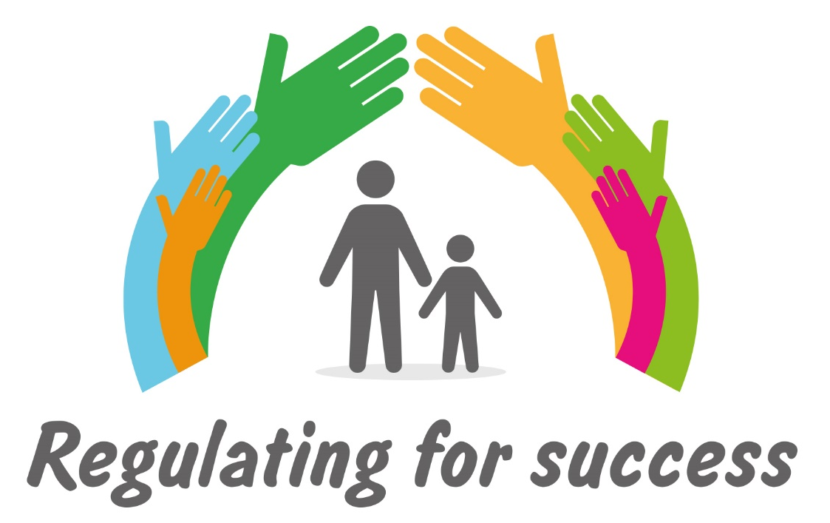

Contents
Section | Page
Introduction | 3
Slides
- Welcome | 5
- Learning environment | 6
- Learning outcomes | 6
- Structure of the day | 8
- Legislation, Regulations and Guidance | 8
- It’s all about well-being | 9
- Social Services and Well-being Act | 10
- What matters and strength-based approaches | 12
- Exercise 1 (option 1) – Principles in practice (Providers) | 14
- Exercise 1 (option 1) – Principles in practice (Inspectors)  - Exercise 1 (option 2) – How well are we doing (Providers)  - Exercise 1 (option 2) – How well are we doing (Inspectors)  - Exercise 1 (option 3) – Giving and receiving (Providers)  - Exercise 1 (option 3) – Giving and receiving (Inspectors)  - Regulation and Inspection of Social Care Act (RISCA) | 15  16  17  18  19  20
- BREAK  - Statements of Purpose – section heading  - Exercise 1 – Purpose of the SOP | 22  22  23
- Why have one? | 25
- Why the Statement of Purpose is important for Providers | 27
- Issues to consider | 28
- Contents of the Statement of Purpose | 30
- About the service provider and location | 31
- About the services provided | 31
- How the service is provided | 33
- Exercise 3 – What we do and how (Providers) | 35
- Exercise 3 – What we do and how (Inspectors) | 36
- LUNCH | 37
- Workforce planning | 37
- Staffing arrangements | 38
- Exercise 4 – Who does it – staffing (Providers) | 42
- Exercise 4 – Who does it – staffing (Inspectors) | 43
- Facilities and services | 44
- BREAK | 45
- Governance and quality monitoring arrangements | 45
- Quality assurance considerations | 46
- Exercise 4 – Doing it right (Providers) | 50
- Exercise 4 – Doing it right (Inspectors) | 51
- Aspects of culture | 52
- Key points | 53
- Key points continued | 54
- Further information | 54
Key resources | 56

Introduction
The Regulation and Inspection of Social Care Services (Wales) Act 2016 provides a revised, streamlined framework for the regulation and inspection of social care services in Wales. The Act has been introduced to improve the quality of care and support in Wales. It will do this by strengthening protection, increasing accountability of those who provide services and giving a stronger voice to people who use care and support services.

A key element of the new regulatory framework is the increased importance of the Statement of Purpose. The Statement of Purpose is a key document that sets out a provider’s vision for services and its aspirations for meeting the needs of the people the service supports. It should clearly demonstrate that the service fully understands individuals’ needs and demonstrate how, particularly through the levels and training of staff, the care routines, the environment and links to other agencies, the service will do its best to promote the best possible outcomes for the people cared for.

In response to the Act being introduced and the guidance provided by Care Inspectorate Wales (A guide to compiling a Statement of Purpose - January 2018) Social Care Wales (SCW) and Care Inspectorate Wales (CIW) have developed a learning resource to support providers in the development of Statements of Purpose that enable the delivery of good quality outcomes for individuals. The resource does not replace or add to the existing legislation and has been developed to support providers, responsible individuals, managers to carry out their duties under the Regulation and Inspection of Social Care (Wales) Act 2016.

This training resource has been written for learning facilitators and includes a PowerPoint presentation, learning resources and exercises that support the learning aims for the training. These facilitator’s notes have been developed to support learning facilitators to deliver the training module. Whilst there is a lot of detail contained in the facilitator’s notes it is not an expectation that all of the detail needs to be shared with learners during the delivery. The information contained provides the facilitator with the context to the points that are highlighted within the PowerPoint presentation and will provide detail that may be helpful when questions arise.

Who is this module for?
This training module is aimed at:

- Regulated service providers (regulated with Care Inspectorate Wales under the Regulation and Inspection of Social Care (Wales) Act) to include as a minimum: Responsible Individuals and Managers
- Regulators and inspectors within Care Inspectorate Wales

The training has been designed for two distinct audiences: providers being the first
audience and regulators/ inspectors being the second audience. Almost all of the
training materials that accompany this training module are applicable to both
audiences. The exception to this is the exercises as these have been designed
separately for each audience. Training that is applicable to providers is indicated
with a (P) and training that is applicable to inspectors is indicated with an (I).

Aims and Learning Outcomes
The aim of the training is to support organisations to ensure the Statement of Purpose (SOP) supports the delivery of a good quality care and support by:
- Learning from the experiences of care providers and CIW in relation to the submission of SOPs in 2018;
- Clarifying the context of the SOP in terms of recent changes in legislation;
- Sharing good practice in relation to writing a good Statement of Purpose.

By the end of the training participants will:
- Be aware of the parts and features of the key legislation that informs the development of a Statement of Purpose;
- Understand the importance of the Statement of Purpose and how it is central to the delivery of good quality outcomes for individuals;
- Understand the process for completing the Statement of Purpose and the areas to be considered;
- Be aware of the key factors that need to be considered when planning a service and how this is described in a Statement of Purpose;
- Be able to identify how it may align with commissioner contract specifications and quality assurance requirements.

Training Module
This training module can be used to assemble a pack of relevant learning materials for each participant to take away. There is a linked PowerPoint presentation and associated resource handouts. The training module matches the PowerPoint presentation and each slide in the presentation is reproduced below.

Slide 1
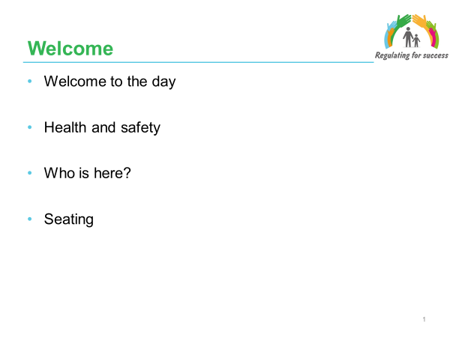

Facilitator Notes
- Welcome people to the session and provide information about any health and safety matters (e.g. fire alarms), washrooms and timings.

- Share the background and context of this work – it has been commissioned by Social Care Wales and Care Inspectorate Wales based on a recognition that there is a need for greater understanding across both providers and the inspectorate of what constitutes a good statement of purpose and to ensure consistency in the content and quality of statements of purpose. This work was developed through consultation with providers, commissioners and inspectors.

- Invite people to introduce themselves, their role (for example Responsible Individual, Home Manager, Registration Inspector) and indicate the service setting they are involved in delivering. In respect of inspectors this can relate to the services they register/inspect.

- Acknowledge that individuals will have different learning styles and so the day has been designed with a range of different activities to support people’s full involvement and participation.

Slide 2
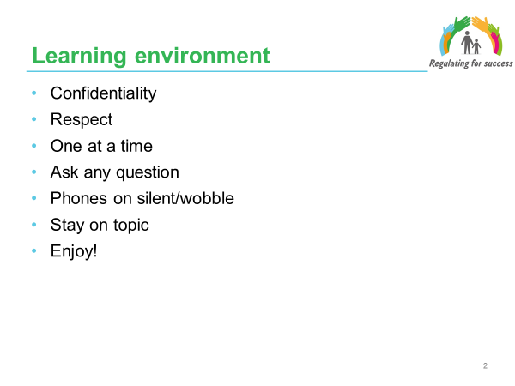

Facilitator Notes
- It is important to establish agreed principles for the learning environment for the day that ensures all participants feel comfortable and confident in contributing to the discussions and participating in the activities throughout the day.

- Invite the group to contribute any additional principles (ground rules) that they would wish to add.

Slide 3
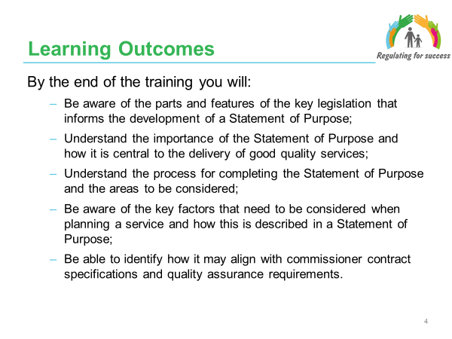

Facilitator Notes
- The aim of the training is to support organisations to ensure the Statement of Purpose supports the delivery of a good quality care and support that promotes positive outcomes for individuals. This is done by:
- Learning from the experiences of care providers and CIW in relation to the submission of SOPs in 2018;
- Clarifying the context of the SOP in terms of recent changes in legislation;
- Sharing good practice in relation to writing a good Statement of Purpose.

- The presentation starts with an overview of the key legislation - Regulation and Inspection of Social Care (Wales) Act, Social Services and Well-being (Wales) Act, Well-being of Future Generations (Wales) Act; although it is assumed that participants have already undertaken general awareness training about the Acts.

- It then moves onto consider the legislative context for the Statement of Purpose and explore the issues that need to be considered when developing a Statement of Purpose.

- Care homes (including children’s homes), Domiciliary Support Services, Residential Family Centres and Secure Accommodation services submitted their Statement of Purpose as part of their registration under the new Act in 2018. Adoption, Fostering, Advocacy and Adult Placement services will be required to register in 2019.

- By the end of the training participants will:
- Be aware of the parts and features of the key legislation that informs the development of a Statement of Purpose;
- Understand the importance of the Statement of Purpose and how it is central to the delivery of good quality services;
- Understand the process for completing the Statement of Purpose and the areas to be considered;
- Be aware of the key factors that need to be considered when planning a service and how this is described in a Statement of Purpose;
- Be able to identify how it may align with commissioner contract specifications and quality assurance requirements.

6. Whilst guidance on the statement of purpose already exists - https://careinspectorate.wales/providing-a-care-service/already-registered-services/re-registration additional learning resources and opportunities (such as this training) will help to improve quality and achieve a more consistent understanding of what a good statement of purpose looks like with a specific focus on:

- Taking a person-centred approach;
- Creating a vision and model of care and support;
- Agreeing aims, objectives and outcomes;
- Planning the right workforce;
- Ensuring on-going quality;
- Describing the plan in a good written statement.

Slide 4
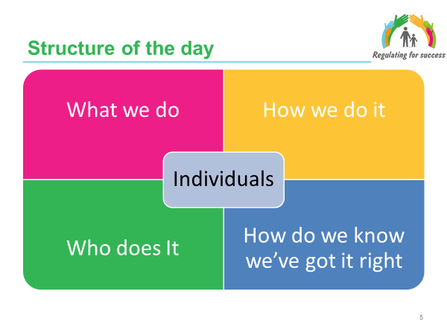

Facilitator Notes
- The day will be focussed on the following elements associated with developing a Statement of Purpose:
  - What we do;
  - How we do it;
  - Who does it;
  - How do we know we’ve got it right.

- It is important that the individuals are the central focus within the statement of purpose and that the detail that is contained within it is focussed on how individuals’ needs will be met and how they will be supported to achieve their personal well-being outcomes.

Slide 5
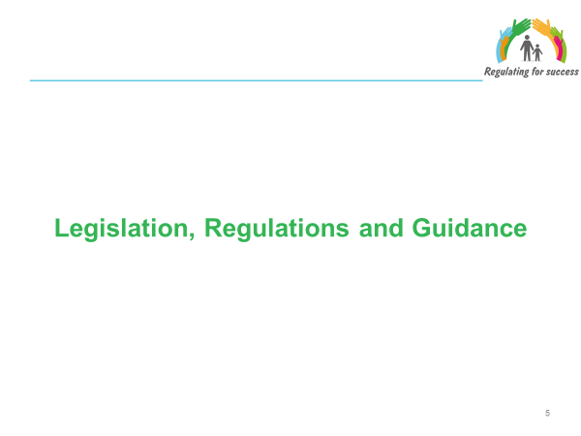

Facilitator Notes
This section will focus on the Social Services and Well-being Act (Wales) 2014 and the Regulation and Inspection of Social Care Act (Wales) 2016 and will draw out the key requirements in relation to the delivery of good quality person centred and outcome focused care and support.

Slide 6
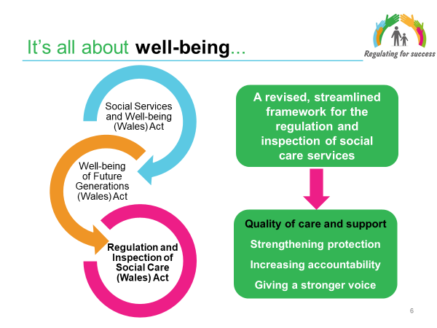

Facilitator Notes
- The Regulation and Inspection of Social Care (Wales) Act 2016 provides a revised, streamlined framework for the regulation and inspection of social care services in Wales.

The Act has been introduced to improve the quality of care and support in Wales. It will do this by strengthening protection, increasing accountability of those who provide services and giving a stronger voice to people who use care and support services.

- The Social Services and Well-being (Wales) Act 2014 reforms and simplifies the law; it repeals many previous laws and guidance relating to care and support and replaces them with this Act. It builds on the White Paper ‘Sustainable Social Services for Wales: A Framework for Action’ to modernise the law for care and support in Wales. It brings in new duties for local authorities, local health boards and other public bodies, and covers adults, children and carers. Note that in these learning materials the term individual is used to mean an adult or child.

- The Future Generations (Wales) Act 2015 is about improving the social, economic, environmental and cultural well-being of Wales. The Act makes public bodies think more about the long term, work better with people and communities and each other, look to prevent problems and take a more joined-up approach. Public bodies need to make sure that when making their decisions they take into account the impact they could have on people living their lives in Wales in the future.

- Taken together, these three pieces of legislation have been described as the most significant legal change to social care in Wales since devolution. Combined they produce a whole system with the aim of improving the well-being of the people of Wales. The themes across all three pieces of legislation are common.

Slide 7

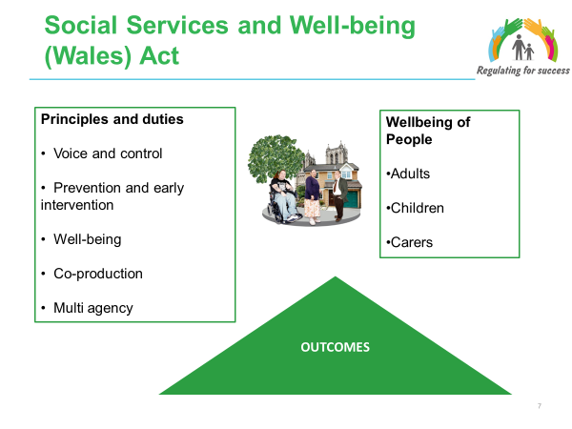

Facilitator Notes
Handout: Well-being and a copy of the National Well-being Statement
Handout: Legislative Duties

- Shown in the box on the left are the key principles that underpin the design of the Act.

- The Act aims to change the way people’s care and support needs are met – putting an individual at the centre of their care and support and giving them a voice in, and choice and control over decisions made about their lives and reaching the personal outcome goals that matter to them.

- Central to the Act is the concept of well-being – helping people to maximise their own well-being supported by their families, friends and communities. In promoting well-being providers have to not only think about people who need care and support now, but those whose needs aren’t eligible or who might have needs in the future. Promoting well-being, therefore, includes focusing on preventing the need for care and support and stopping people’s needs from escalating as well as providing people with the information, advice and assistance they need to take control over their day-to-day life.

- Practitioners must look at what people can contribute in achieving their well-being and empower them to contribute to achieving their own well-being, with the appropriate level of support. This will involve building on people’s resources, including people’s strengths, abilities and families and communities.

- In the Act well-being is defined with eight common aspects:
- physical and mental health, and emotional well-being;
- protection from abuse and neglect;
- education, training and recreation;
- domestic, family and personal relationships;
- contribution made to society;
- securing rights and entitlements;
- social and economic well-being; and
- suitability of living accommodation.

In relation to an adult, well-being also includes:
- control over day-to-day life; and
- participation in work.

In relation to a child, well-being also includes:
- physical, intellectual, emotional, social and behavioural development; and
- “welfare” as that word is interpreted for the purposes of the Children Act.

- While all aspects of well-being in the definition have equal importance, it is likely that some aspects of well-being will be more relevant to one person than another. Practitioners should therefore adopt a flexible approach that allows for a focus on which aspects of well-being matter most to the adult concerned and co-produce solutions with people.

- The Act attempts to rebalance the focus of care and support to prevention and earlier intervention – increasing preventative services within the community to minimise the escalation of needs to a critical level.

- Strong partnership working between organisations and co-production with people needing care and support is a key focus of the Act. The Act requires a culture change from the way in which services have often been provided, to an approach based on collaboration, and an equal relationship between practitioners and people who need care and support and carers who need support.

Slide 8
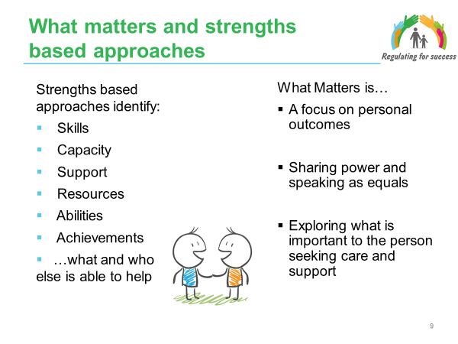

Facilitator Notes
- A strength-based approach is fundamental to person centred working.

- In carrying out an assessment, local authorities must work with people to identify what matters to them. People will wish to achieve different aspects of well-being, dependent on their circumstances, and these make up personal outcomes.

- Local authorities must consider the personal outcomes that an individual wishes to achieve, the resources available, and how the local authority may support them to achieve these. Central to this will be understanding the barriers that a person may face in achieving their personal outcomes.

- Assessment starts from the presumption that an adult is best placed to judge their own well-being and the personal outcomes they wish to achieve based on their own values and what matters to them. Engaging effectively in a ‘what matters to me’ conversations requires practitioners to: listen rather than tell; resist rescuing or fixing; empathise and work with the adult not the presenting behaviour.

- Children should be supported to identify what matters to them by a range of practitioners and other people involved with them including their family and friends. Engaging effectively in a ‘what matters to me’ conversation requires practitioners to: listen rather than tell; see the child as a resourceful young person; and empower the child and work with them not the presenting behaviour.

- Individuals usually know what will help them. In keeping with the voice, choice and control principle that runs throughout the Act, service recipients must be fully engaged.

- Strengths-based models of practice challenge approaches that focus assessment on ‘what is wrong’, problems and weaknesses and seek, instead, to build upon the knowledge, abilities and achievements of the person being assessed. “A strengths-based approach to care, support and inclusion says let’s look first at what people can do with their skills and their resources and what can the people around them do in their relationships and their communities. People need to be seen as more than just their care needs – they need to be experts and in charge of their own lives.” (Alex Fox, Shared Lives)

- The strengths-based approach is about reducing dependency and challenging the ‘prescription culture’ but also, crucially, protecting the person’s independence, resilience, choice and well-being. In practical terms it could mean anything from the way a practitioner/assessor approaches discussions around needs for support to providing services that focus on re-ablement or habilitation and strengths.

- Strengths-based approaches require a different set of skills. In particular the ability to help people identify and explore strengths and then make creative use of them in overcoming barriers and achieving outcomes. Part of this might include exploring opportunities for individuals to contribute as well as just receiving support.

- It is important to highlight that prior to service providers supporting individuals the Social Worker/ OT will have started this approach through the assessment and care and support planning process and so providers will need to consider how they continue with this approach as they develop relationships with individuals and formulate personal plans.

- These are key approaches to how we have conversations with people, how we approach assessments and care and support planning and how we deliver services
FOR THE ATTENTION OF FACILITATORS - Slides 9-14 provide three different activity options – the aim is to identify one activity (for either providers or inspectors) for this part of the training. The selection of the appropriate activity will need to be determined by a judgement on the level of knowledge and understanding of the Social Services and Well-being Act amongst the participants.

It will be important to remove the slides that are not required from the supporting PowerPoint presentation for delivery.

Slide 9 (Option 1 – Providers)
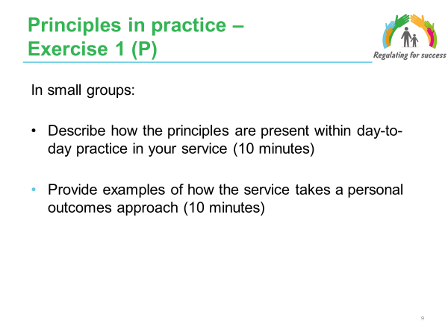

Facilitator Notes

The purpose of this activity is to focus participants’ thinking on the key principles of the SSWB Act and how it has influenced / changed their approach.

It is also helpful for providers to be able to define and express their ethos and models and of care.

Participants are to also give thought to how this could be expressed in Statements of Purpose

Facilitator Notes - Exercise
In pairs:
- Describe how the principles are present within day-to-day practice in your service (10 minutes);
- Provide examples of how the service takes a personal outcomes approach (10 minutes).

Slide 10 (Option 1 – Inspectors)

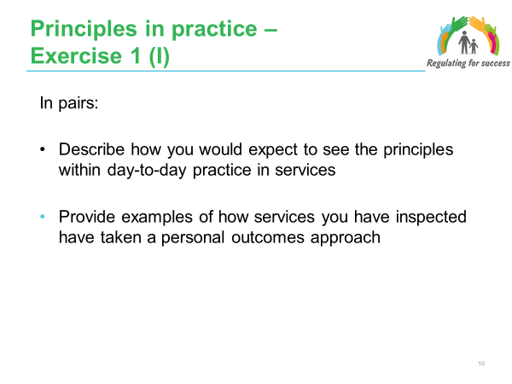

Facilitator Notes

The purpose of this activity is to focus participants’ thinking on the key principles of the SSWB Act and how it has influenced / changed their approach.

Participants are to also give thought to how this could be expressed in Statements of Purpose.

Facilitator Notes - Exercise
In pairs:
- Describe how you would expect to see the principles within day-to-day practice in services (10 minutes);
- Provide examples of how services you have inspected have taken a personal outcomes approach (10 minutes).

Slide 11 (Option 2 – Providers)
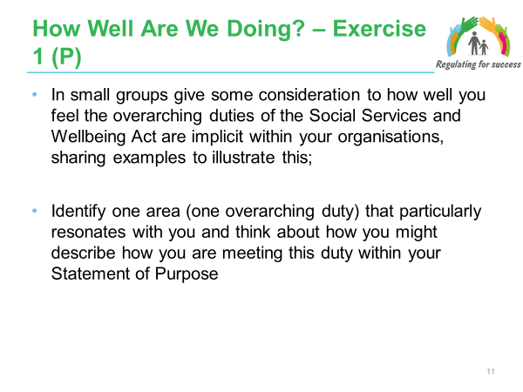

Facilitator Notes

Refer to the Handout – Legislative Duties
The purpose of this activity is to focus participants’ thinking on the key duties of the SSWB Act and how they are being implemented in practice within their services. It is also helpful for providers to be able to define and express this in their ethos and models of care.

Participants are to also give thought to how this could be expressed in Statements of Purpose.

Facilitator Notes - Exercise
- In small groups give some consideration to how well you feel the overarching duties of the Social Services and Well-being Act are implicit within your organisations, sharing examples to illustrate this (10 minutes);
- Identify one area (one overarching duty) that particularly resonates with you and think about how you might describe how you are meeting this duty within your Statement of Purpose’ (10 minutes)

Slide 12 (Option 2 – Inspectors)

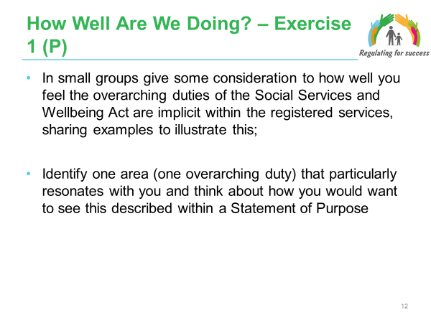

Facilitator Notes
Refer to the Handout – Legislative Duties

The purpose of this activity is to focus participants’ thinking on the key duties of the SSWB Act and how they are being implemented in practice within services. It is also helpful for providers to be able to define and express this in their ethos and models and of care.

Facilitator Notes - Exercise
- In small groups give some consideration to how well you feel the overarching duties of the Social Services and Well-being Act are implicit within your organisations, sharing examples to illustrate this (10 minutes);
- Identify one area (one overarching duty) that particularly resonates with you and think about how you might describe how you are meeting this duty within your Statement of Purpose’ (10 minutes).

Slide 13 (Option 3 – Providers)
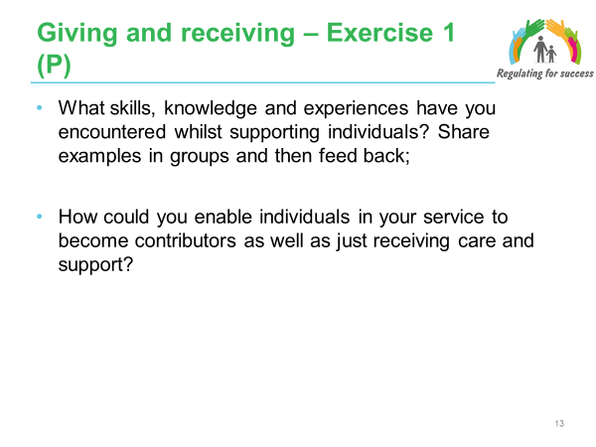

Facilitator Notes
The aim of this exercise is to emphasise to the group the importance of reciprocity in care as a two way process, for example “It’s better to give than receive”.

Facilitator Notes – Exercise
- Divide the whole group into small groups for the first part of the exercise – What skills, knowledge and experiences have they encountered whilst supporting people? Share examples in groups (10 minutes);
- For the second part of the activity in a large group - How could services enable people to contribute within their service and become contributors as well as just receiving care and support (10 minutes).

Encourage participants to discuss the benefits and rewards of giving.

Slide 14 (Option 3 – Inspectors)

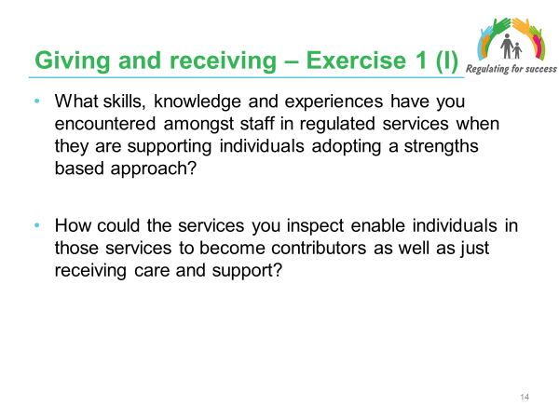

Facilitator Notes
The aim of this exercise is to emphasise to the group the importance of reciprocity in care as a two way process, for example “It’s better to give than receive”.

Facilitator Notes – Exercise
- Divide the whole group into small groups for the first part of the exercise – What skills, knowledge and experiences have they encountered amongst staff in regulated services when they are supporting individuals adopting a strengths based approach. Share examples in groups (10 minutes)
- For the second part of the activity in a large group - How could services they inspect enable individuals in those services to contribute within their service and become contributors as well as just receiving care and support (10 minutes).

Encourage participants to discuss the benefits and rewards of giving

Slide 15
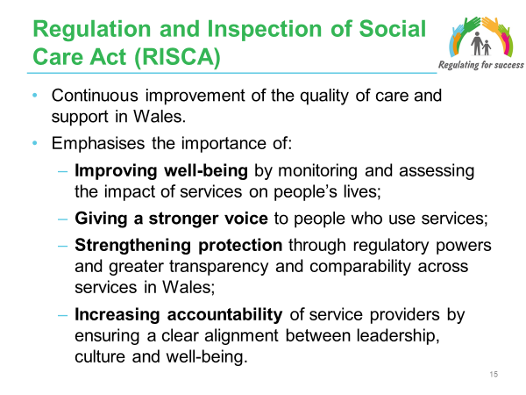

Facilitator Notes
- The Regulation and Inspection of Social Care (Wales) Act 2016 changes the regulation and inspection of social care in Wales. It places service quality and improvement at the heart of regulation, strengthens protection for those who need it, and ensures services deliver high-quality care and support.

- This Act supports the aims of the Social Services and Well-being (Wales) Act 2014 which enshrines the rights of people using care and support services into law.

- The Act is also about regulating for success:
- From compliance with minimum standards to how services improve people’s well-being. Prior to the Act, the system of regulation was predominately focused on compliance with minimum standards. The new approach takes greater account of the impact which care and support services have on people’s lives and well-being.
- Reducing complexity of the law and providing flexibility - The aim is also to reduce the complexity of the law and provide greater flexibility of processes for providers, and enable new models of care to develop. As an example – nine sets of regulations and 14 sets of minimum standards will be replaced by just two sets of regulations and guidance on compliance with those regulations.
- Developing workforce skills to provide the best care and support - In addition to making changes to the registration, inspection and enforcement of care and support, the Act includes requirements for the regulation of the social care workforce to ensure that everyone who works in the sector is skilled, appropriately qualified and trained to an agreed set of standards.
- Increasing transparency and public confidence - The regulators will have duties to involve citizens in their work and report on how this is done annually. Providers will have a duty to produce and publish annual returns that give objective information for the public. Greater transparency and public awareness, it is hoped, will lead to greater public confidence in how regulation works.

- The Act rebalances accountability in the social care system, away from just those working on the frontline to ensure employers, company owners and directors are accountable in law.

- There are five main elements to the Act:
- The Act establishes Social Care Wales;
- Regulation of the workforce across all care and support provision in Wales through SCW;
- Regulation of social care service providers: care homes, domiciliary care agencies, etc (regulated services) through CIW;
- Inspection of and reporting by local authorities;
- Market stability reports and market oversight.

- The Act is also concerned with:
- How organisations share information and work together;
- Being consistent with changes and principles delivered by the Social Services and Well-being (Wales) Act 2014.

- The Act will affect the whole care and support sector: a wide range of organisations, managers, staff and people who use regulated care and support services.

- Regulated services are the ones shown in this slide: a care home service; a secure accommodation service; a residential family centre service; an adoption service; a fostering service; an adult placement scheme; an advocacy service or a domiciliary support service.

- Childcare homes will be classed as care homes under the new service regulations. Note that a care home service includes nursing homes as well as residential homes.

- The Act will affect providers of all types – local authorities, voluntary and community sector providers, not-for-profit and private sector provider organisations or individuals – providing regulated services for all types of individuals such as people with learning disabilities, mental health services, children’s services, older people’s services, etc.

Slide 16

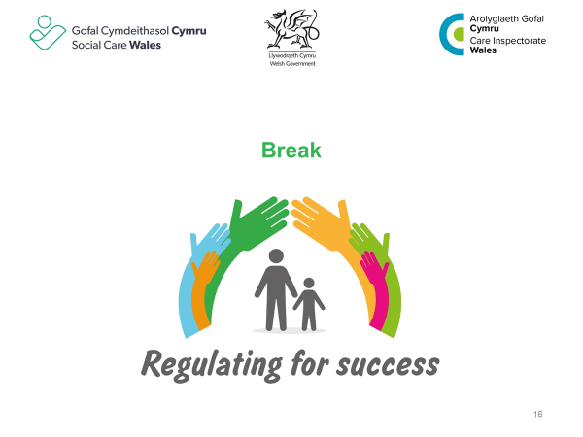

Slide 17
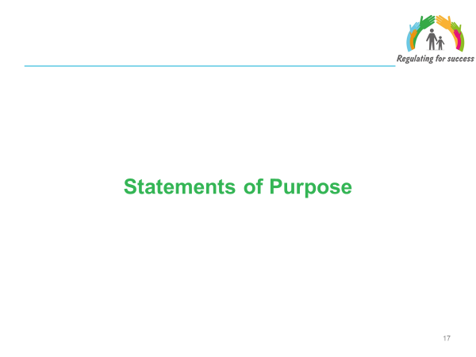

Facilitator Notes
- Under the Regulation and Inspection of Social Care (Wales) Act 2016, as a key part of the registration process, service providers are required to prepare a statement of purpose for each service they provide and submit this to Care Inspectorate Wales (CIW).
- The statement of purpose takes on even more importance under the Regulation and Inspection of Social Care Act as there will no longer be ‘categories’ as conditions of registration. It sets out the vision for the service and the aspirations for meeting the needs of the people cared for.
- The Statement of Purpose must clearly demonstrate that the provider understands the needs of the individuals receiving support from the service and has in place the right workforce to meet those needs and support people’s well-being.

Slide 18

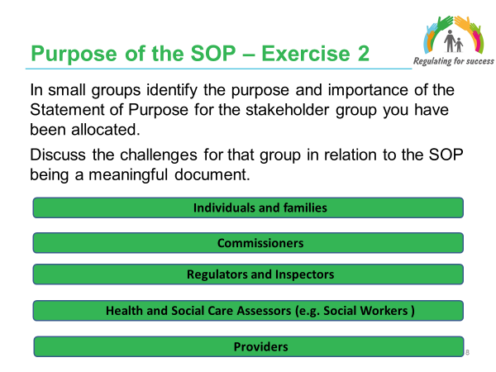

Facilitator Notes
- The aim of this exercise is to identify the purpose and importance of the Statement of Purpose from the perspectives of different stakeholders.

Facilitator Notes - Exercise
- Divide the whole group into 5 groups – and allocate a stakeholder group to each: Regulators/ Inspectors; Commissioners; Providers; Individuals/ families; Social Care Assessors.
- Each group has 20 minutes to identify what the purpose and importance of the Statement of Purpose is for their allocated group and the challenges in terms of it being a meaningful document. Challenges may be different to each group, for example:
- For individuals and families this may relate to accessibility and clarity;
- For commissioners this will include issues relating to the fact that there are no ‘categories’ (such as dementia) anymore and hence the SOP becomes even more pivotal in terms of ensuring quality and in determining fee levels;
- For regulators and inspectors, they now need to factor how well the provider is meeting the SOP into their judgements;
- For Social Workers it supports decision making with regards to identifying the most suitable options for meeting an individuals' needs and outcomes – and that this continues to be the case as services are provided;
- For providers it defines who the service is for and how it is provided; there is a challenge in pitching it to meet the requirements of a range of stakeholders and considering how they keep it a living document.
- Final feedback is then sought from the groups with examples taken for each stakeholder group (20 minutes).
- Post the sheets on the wall and draw out one or two key points for each stakeholder group.

Exercise – Possible Responses
- The table below provides additional points in relation to the purpose and importance of the Statement of Purpose – these can be shared if they do not come up in the whole group feedback.

Stakeholder group | Purpose and importance of the Statement of Purpose
Individuals and families | - Provides clear and understandable information about the service;  - Provides accurate information about the service provided e.g. details about activities within the setting; how individual needs and preferences will be met (e.g. language and religious needs);  - Provides information about the complaints/ concerns process (as linked with the requirements relating to quality assurance);  - Provides information about the staff in the setting;  - Provides information about the culture within the setting;  - Supports and enables informed decision making about the support they wish to receive.
Commissioners | - To support market shaping;  - To ensure sufficiency of placements;  - Establish value for money;  - Consistency between contract monitoring and regulation/ inspection;  - To inform the detail of specifications and contracts;  - Provides a benchmark for the quality of the service.
Regulators and inspectors | - Provides a benchmark to judge if outcomes are being met;  - Provides a benchmark as to whether the services is delivered in practice as is set out in the description in the SOP;  - A key source of information in making registration determinations;  - A tool for inspecting and holding providers to account.
Health and Social Care Assessors | - Provides information to inform a decision as to whether the service can meet the needs of the individual;  - Supports more flexibility in how services are delivered (e.g. as a result of categories being removed).  - Provides a benchmark as to whether the services is delivered in practice as is set out in the description in the SOP;  - Supports consistency between care and support planning arrangements (assessors and providers processes).
Providers | - Supports compliance with legal requirements;  - Informs stakeholders about who the service is provided for, what is provided and how it is provided;  - Ensures the organisation and staff have a shared understanding of the service;  - Contains information that supports self assessment and review and helps to keep the SOP alive (as linked with the requirements relating to quality assurance);  - Development and education tool for staff.

Slide 19

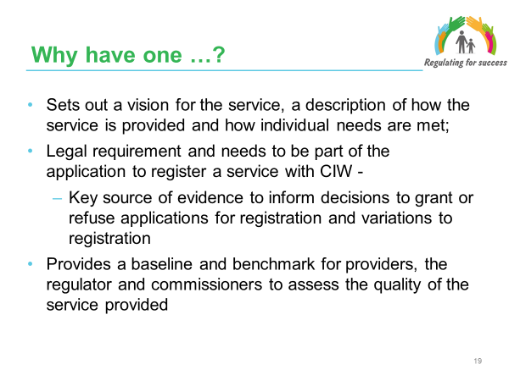

Facilitator Notes
- The statement of purpose is a key document. It sets out the vision for the service and aspirations for meeting the needs of people the service cares for:
- demonstrates that the service fully understands the individual’s needs;
- demonstrates how (through levels and training of staff, care routines, the environment and links to other agencies) the service will do its best to promote the best possible outcomes for people the service cares for.

- It should clearly demonstrate that the service fully understands the needs of individuals and demonstrate how, particularly through the levels and training of staff, the care routines, the environment and links to other agencies, the service will do its best to promote the best possible outcomes for the people they care for.

- The information in the statement of purpose must be accurate, kept up to date and should always reflect the range of needs the service is able to meet, including any specialist services. In preparing or updating a statement of purpose, service providers should consider the offence of making a false statement under section 47 of the Regulation and Inspection of Social Care (Wales) Act 2016 (the 2016 Act).

- The statement of purpose is a legal requirement. If a provider makes an application to register a service with CIW it has to include a statement of purpose as part of the application. This will tell CIW:
a) details about the service;
b) where the service is located;
c) the type of the service provided;
d) the aims and objectives of the service; and
e) how the service will be provided.

- When considering an application to register, CIW will need to be satisfied that the service will make proper provision for the well-being of people and is able to meet the standards required in the regulations. The statement of purpose will be a key source of evidence used by CIW to inform decisions to grant or refuse applications for registration and variations to registration.

- Schedule 2 of The Regulated Services (Registration) (Wales) Regulations 2017 sets out the information which must, as a minimum be included within the statement of purpose.

- Regulations 3, 4, 6, 7 and 8 of The Regulated Services (Registration) (Wales) Regulations 2017 places specific requirements on the provider in relation to the statement of purpose when making an application to register or vary a regulated service. 5.3.

- In addition, the statement of purpose is referenced in many of the Regulations within The Regulated Services (Service Providers and Responsible Individuals) (Wales) Regulations 2017. These regulations set out the requirements in relation to service providers and responsible individuals.

Slide 20
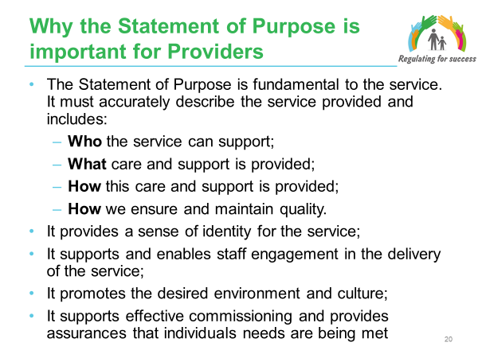

Facilitator Notes
- The Statement of Purpose helps to describe “who we are” and sets out “what we do” and “how we do it”. Providers describe how the service will be provided with details about what they do and how they meet individuals’ needs and promote positive outcomes for them. It should also describe the philosophy of how it operates.

- It supports staff engagement and it is imperative that staff know about it and understand it as it is a source of guidance on how the service operates and the ethos of the service within which they work.

- The Statement of Purpose can help to create the right environment and culture in that it should convey the importance of creating the right environment within the service that provides positive role models.

- Think of it as a form of service specification of the matters “you need to think about”.

- In preparing a statement of purpose, the provider must take account of any relevant guidance published by CIW.

- Partnership working between commissioners (health and social care) and providers (and citizens accessing services) needs to be in place to develop commissioning priorities and service specifications alongside provider development of statements of purpose. This is often not commonplace at present and the role that providers can play in understanding the market and identifying solutions is not maximised despite the presence of local provider forums and a National Providers Forum and providers are not sufficiently involved in the commissioning cycle. It is important to ensure consideration is given to what both health and social care commissioners will be looking for within a Statement of Purpose.
- The statement of purpose also has the potential to support commissioners and providers to be innovative and define and develop new models of care that go beyond the traditional models of delivery (many of which have been confined to the old system of category registration). The development of the Statement of Purpose also helps to recognise the potential contribution of existing assets, services and the workforce.

Slide 21
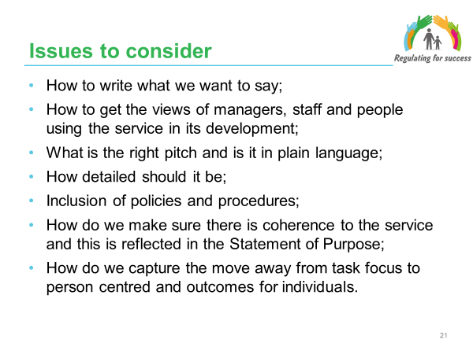

Facilitator Notes
- This slide considers some of the challenges that providers have highlighted as key areas for consideration when developing a Statement of Purpose.

- It is important that the Statement of Purpose covers the regulatory requirements (which we will consider in this next section) but allows the provider to describe its service in their own words, in accordance with the ethos and culture of the organisation. It’s not a promotional document.

- In getting the language right the focus needs to be on ensuring it is understandable and clear to all those who will read/access it. It is important to be clear about who the audience is and who it is intended for. As we discussed in an earlier activity the Statement of Purpose is important and has a purpose for a range of stakeholders (as providers, commissioners, regulators and inspectors and individuals and families).

- In developing the Statement of Purpose some providers have used very inclusive approaches to involving managers, staff and individuals using the service. This included developing information packs for managers prior to meetings and involving young people.

- The Statement of Purpose however, is no longer regarded as a marketing document per se in that the regulations do not require the Statement of Purpose to be formally published and shared. The service provider must provide an up to date statement of purpose to any person on request, unless it is not appropriate to do so or would be inconsistent with the well-being of an individual. In addition, the provider is required to provide information about the service through the Written Guide (given to all individuals who are receiving care and support) and the production of the Annual Return.

- Policies and procedures need to be proportionate to the service being provided in accordance with the statement of purpose. It is important that they:
- are aligned to any current legislation and national guidance;
- provide guidance for staff to ensure that services are provided in line with the statement of purpose; and
- set expectations to inform individuals and their representatives about how the service is provided.

- The Statement of Purpose needs to include a summary of the policies and procedures that are relevant to the Statement of Purpose but not include extensive detail of all policies and procedures and their content. For example, a summary of the admission procedure is included in the statement of purpose and the service provider’s guide to the service.

- Where changes are made to the statement of purpose the policies and procedures are reviewed and updated to reflect the changes.

- It is important that there is coherence within the service and that this is described within the Statement of Purpose. In that there is a service wide vision and whole system approach to delivery and the different aspects of delivery support the achievement of the vision. In a similar way it is important that the Statement of Purpose comes together as a whole document with each of the sections relating to each other – in that it describes the logic and whole system approach to service delivery.

Slide 22
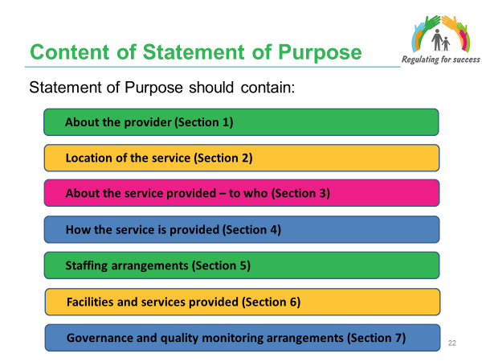

Facilitator Notes
Handout: Statements of Purpose AND Statement of Purpose template

- Under the Regulation and Inspection of Social Care (Wales) Act 2016, as a key part of the registration process, service providers are required to prepare a statement of purpose for each service they provide and submit this to Care Inspectorate Wales (CIW).

- Schedule 2 of The Regulated Services (Registration) (Wales) Regulations 2017 sets out the information which must, as a minimum be included within the statement of purpose.

- The Statement of Purpose template and associated guidance issued by Care Inspectorate Wales (A Guide for compiling a Statement of Purpose - January 2018), includes the following sections. Whilst a template has been provided it has been done so as a guide and there is no statutory requirement to complete the template. Where the template is not used the content of the Statement of Purpose must include the information required in accordance with Schedule 2 of the Regulations.

- CIW have produced ‘Guide to Compiling the Statement of Purpose’. CIW guidance and notes contained in the template should be considered when completing the Statement of Purpose and making an application for registration

Slide 23
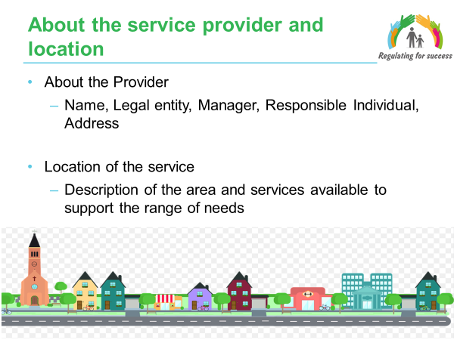

Facilitator Notes
- This slide covers the detail of the information required in Sections 1 and 2 of the Statement of Purpose template.

- It is important that the description of the location of the service, the area and services available give consideration to how the local area and services can support the identified range of needs (as identified in Section 3 of the Statement of Purpose template).

- Providers must be clear about their legal entity (About the Provider).

Slide 24
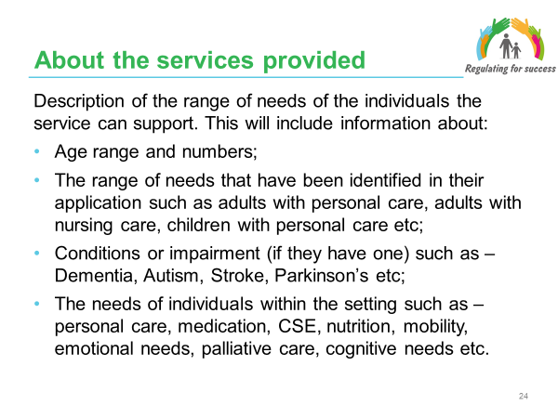

Facilitator Notes
- This slide covers the detail of the information required in Section 3 of the Statement of Purpose template.
- This section requires Providers to identify who they can provide support to – i.e. the range of needs they can support. It is a key area with the removal of categories of registration.

- This section needs to include information about:
- The range of needs that have been identified in the CIW application (e.g. adults with personal care, adults with nursing care, children with personal care, children with nursing care, learning disabilities and mental health).
- Conditions or impairment (if they have one) such as – dementia, brain injury, autism, sensory impairment etc.
- The needs of individuals within the setting such as – personal care, medication, nutrition, mobility, emotional needs, palliative care, cognitive needs etc.

- Under the new arrangements for registration and regulation there will no longer be the application of categories. Instead the emphasis is now on identifying and meeting the needs of the individuals supported within regulated services. The intention being that it will give providers more flexibility to respond to the needs, provide continuity of care to individuals and empower individuals to exercise choice and control in how their needs are met.

- It is important that the Statement of Purpose describes the range of needs the service can support. Consideration needs to be given to the fact that just because people have the same condition (e.g. dementia, acquired brain injury, Parkinson’s) it does not mean they have the same individual needs and desired personal outcomes.

- In identifying the range of needs of the individual, consideration must be given to how these needs can fluctuate (as a result of a wide range of factors) and how these are to be described.

- Providers need to keep abreast of research about the needs (and fluctuating needs) of the individuals they support to ensure they continue to provide the most appropriate care and support services to meet these needs.

Slide 25
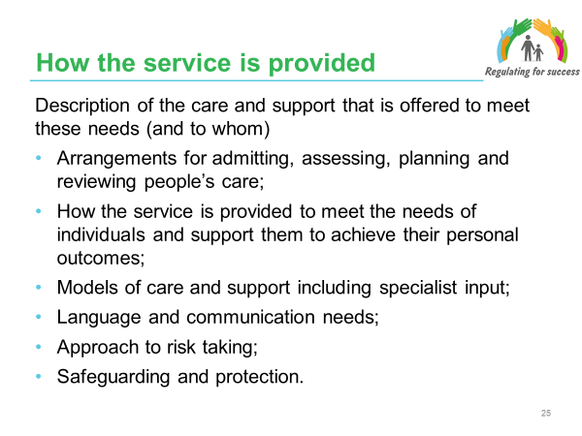

Facilitator Notes
- This slide covers the detail of the information required in Section 4 of the Statement of Purpose template.

- This section requires Providers to identify ‘how’ the service is provided. It is important that Providers identify the needs of the individuals that they support (section 3 of the Statement of Purpose template), with recognition of how these needs can fluctuate, and to then identify the care and support that is provided that supports these needs.

- Arrangements for admitting, assessing, planning and reviewing people’s care;

This element needs to describe the arrangements the service has in place and how they compliment similar arrangements that are in place within social and health care in order to ensure there is consistency and continuity for the individual being supported.

- How the service is to be provided to meet the needs of individuals and support them to achieve their personal outcomes;

The description of the care and support that is offered to meet the identified needs of individuals should not be about providing a comprehensive list of services that are offered – rather it is about making the link between what is offered and how this will support meeting the needs and outcomes of the individuals.

The standards of care detailed within the SOP template relate closely to the statutory duties and the definition of well-being set out in the Social Services and Well-being Act.

This section could for example detail the type, level and amount of contact individuals will be provided/ supported to engage with, for example involvement of family and friends in supporting the individual to have their needs met and achieve their personal well-being.

There should also be consideration as to how the individual will be supported to actively exercise voice, choice and control (where practicable and appropriate) about how they wish for their needs to be met and outcomes achieved.

- Models of care and support including specialist input - this is an opportunity to talk about models of care based on recognised theoretical principles. Linked to this consideration can be given to in-house and external resources and specialist services.

- Language and communication needs - The active offer of the Welsh language is a requirement set out in the Social Services and Well-being Act and how the Provider promotes this needs to be described in the Statement of Purpose. It is important to emphasise that the active offer is a core component of the delivery of person-centred care and support. Neither should this section be focused solely on the availability of Welsh speaking staff. Consideration needs to be given to how individuals are supported to use and access support and activities through the Welsh language and immerse themselves in customs and traditions of the Welsh culture.

There also needs to be recognition of wider language and communication needs (not solely the Welsh language) of the individuals supported by the service and how individuals will be supported these will be supported with these.

- Approach to risk taking - This needs to be explicit within the Statement of Purpose. Consideration needs to be given to how the service supports shared and positive risk taking and does not focus solely on the elimination of risk.

- Safeguarding and protection - This needs to be explicit within the Statement of Purpose. It is important to draw the distinction between broader safeguarding activities (preventative support, promoting well-being) and the specific duties in relation to protecting individuals who are experiencing or who are at risk of abuse, harm and neglect.

- Ultimately it is about understanding the individuals the service supports and there being value to the support that is provided.

Slide 26
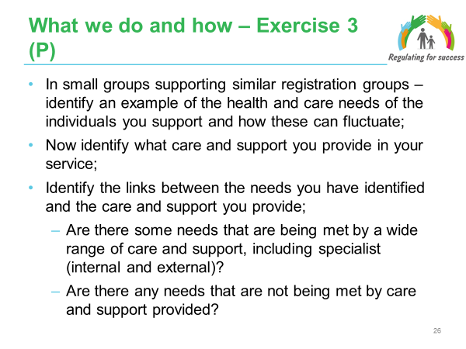

Facilitator Notes
- An example could relate to an individual or group of individuals being supported. Ask people to do each exercise separately.

- The purpose of this activity is to focus participants’ thinking on the needs of the individuals they support and how they identify the care and support that is required/ available to meet those needs.

- Encourage participants to share examples of how they have described the needs of individuals in their Statements of Purpose.

Facilitators Notes - Exercise:
- Divide the group into groupings. Groupings should ideally (although flexibility in terms of those in attendance) be ‘Adult care homes’, ‘Domiciliary support services’, ‘Care homes for children’.

- Groups identify an example of health and care needs of the individuals they support on one sheet (15 minutes).

- Groups then identify the care and support they provide on another sheet (15 minutes).

- Groups then identify if the care and support they have identified can meet the needs of the individual – making the match across the two lists (10 minutes).

- Final large group feedback (10 minutes)

- Share the case examples of Sections 3 and 4 of the Statement of Purpose to illustrate how these sections can be written.

Slide 27
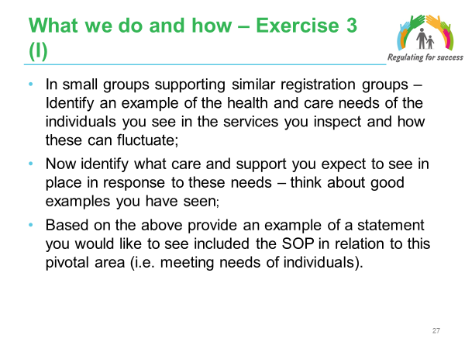

Facilitator Notes
- An example could relate to an individual or group of individuals being supported.

- The purpose of this activity is to focus participants’ thinking on the needs of individuals and how providers might identify the care and support that is required/ available to meet those needs. It also provides an opportunity for providers to be able to define and express models and ethos of care.

- Participants to share examples of how this could be expressed in Statements of Purpose

Facilitators Notes - Exercise:
- Divide the group into groupings that inspect the same/ similar client groups and/or settings. Groupings should ideally (although flexibility in terms of those in attendance) be ‘Adult care homes’, ‘Domiciliary support services’, ‘Care homes for children’. Ask people to do each exercise separately.

- Groups identify an example of health and care needs of the individuals they see within settings they inspect and examples of the care and support they expect to see to meet these needs (15 minutes).

- Based on the above provide an example of a statement you would like to see included the SOP in relation to this pivotal area (i.e. meeting needs of individuals) (10 minutes).

- Final large group feedback (10 minutes)

- Share the case examples of Sections 3 and 4 of the Statement of Purpose to illustrate how these sections can be written.

Slide 28
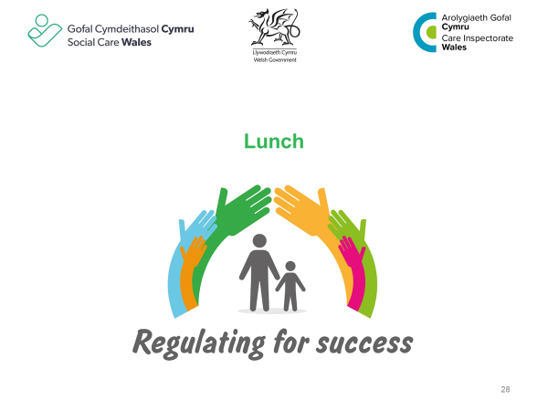

Slide 29
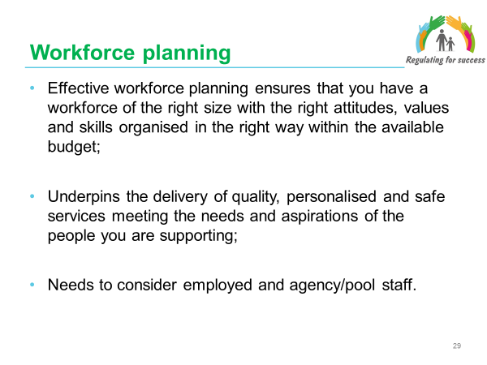

Facilitator Notes
- References here are taken from ‘Practical approaches to workforce planning: A guide to support workforce planning processes and plans for adult social care support services’ (November 2015) – Skills for Care.

- It is important to consider the new arrangements for workforce registration within Wales:
- Mandatory registration of parts of the social care workforce;
- Regulation includes care worker training and qualifications;
- Code of Professional Practice for Social Care and Practice Guidance;
- Post Registration Training and Learning (PRTL);

This is in addition to the existing requirements for DBS checks.

- Being on the Social Care Wales register includes a requirement to be appropriately qualified. Registration also brings recognition and support and gives people receiving care (and their families) the confidence that a worker has the skills and qualifications to do their job in a professional, compassionate manner. Other benefits to registration include:
- Building trust and confidence;
- Valuing staff;
- Making sure people are safe;

- Social Care Wales will investigate if ‘fitness to practise’ for any member of staff is impaired.

- It is important that both employed and agency/pool staff are familiar with the SOP. It may also be good practice to provide agencies with a copy of the SOP in advance.

Slide 30
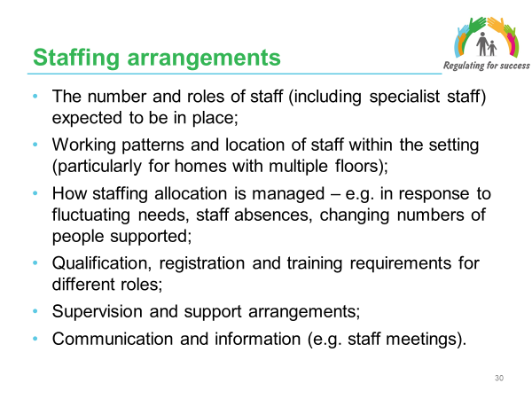

Facilitator Notes
- This slide covers the detail of the information required in Section 5 of the Statement of Purpose template.

- The focus of this section is on providing a description of how staffing arrangements are appropriate for the range of needs and specialist services as described in Section 3 of the Statement of Purpose.

- It is focused on demonstrating how staff are/will meet the needs of individuals. The level of detail needs to reflect this purpose and does not require extensive detail about the qualifications and training of all individual members of staff (other than managers and senior staff), rather it is describing the qualifications and training staff are expected to have/achieve. It also requires information in relation to how the service plans training and best deploys staff to meet the needs of individuals.

- This section will include details of the management and staffing structure of the service.

- The number and roles of staff (including specialist staff) expected to be in place - Expectations in relation to the required numbers and roles of staff and managers to be employed within the service, for example the Statement of Purpose could state ‘our expectation is that the service will employ x number of care staff; x number of ancillary staff (e.g. maintenance, cleaning, catering); x number of senior staff; x number of deputies.

The information provided needs to include the detail of specialist staff employed by the service/ accessed through external agencies.

It is important however to provide more detail in relation to the manager and/or deputies with regards to the qualifications they hold and training undertaken.

- Location of staff within the setting - Part 10 of the Regulated Services (Service Providers and Responsible Individuals) (Wales) (Regulations 34 – 39) specifies requirements to ensure that individuals are supported by appropriate numbers of staff who have the knowledge, competency, skills and qualifications to provide the levels of care and support required to achieve individual’s personal outcomes and meet the needs of individuals as set out in the Statement of Purpose. This will include information about staffing levels that will normally be in place on a day to day basis, this could include sample rotas (names are not necessary).

Where individuals are assessed as requiring nursing care the arrangements for nursing staff within the service need to be detailed.

- How staffing allocation is managed – An overview of the approaches/models used for allocating staff within the service, for example in response to fluctuating needs, staff absences, changing numbers of people supported within the service. An example of this may be the Dependency Model.

Regulation 34(3) of the Regulated Services (Service Providers and Responsible Individuals) (Wales) states that the service provider must be able to demonstrate the way in which the determination has been made as to—
(a) the types of staff deployed, and
(b) the numbers of staff of each type deployed.

- Qualification, registration and training requirements for different roles - Expectations in relation to the required qualifications and training of staff and managers to be employed within the service, for example the Statement of Purpose could state ‘our expectation is that the service will employ x number of care staff who have x (qualification); x number of ancillary staff (e.g. maintenance, cleaning, catering) who have x (qualification).

It is important however to provide more detail in relation to the manager and/or deputies with regards to the qualifications they hold and training undertaken.

Statutory guidance for service providers and responsible individuals on meeting service standard regulations for registered providers indicates that:
- all staff should have an annual appraisal which provides feedback on their performance and identifies areas for training and development in order to support them in their role;
- additional training, learning and development needs of individual staff members are identified within the first month of employment and reviewed through the supervision and appraisal process;
- staff are supported to undertake training, learning and development to enable them to fulfil the requirements of their role and meet the needs of individuals using the service;
- the service provider undertakes an annual (or sooner if changes require it) training needs analysis to ensure that staff have the relevant skills, and competence.

The details of training to be provided to staff needs to be summarised within the section, ensuring that the training is relevant to meeting the needs of the individuals supported by the service.

The challenge here is how to describe the expertise of managers and staff and recognise their skills and experiences that have built up over the years.

- Supervision and support arrangements - Statutory guidance for service providers and responsible individuals on meeting service standard regulations for registered providers indicates that:
- staff meet for one to one supervision with their line manager no less than 2 monthly;
- registered nursing staff have the opportunity for clinical supervision;
- all staff should have an annual appraisal which provides feedback on their performance and identifies areas for training and development in order to support them in their role.

Note: this level of detail does not need to be included in the Statement of Purpose but as a minimum there should be recognition that these arrangements are in place.

- Communication and information sharing - Statutory guidance for service providers and responsible individuals on meeting service standard regulations for registered providers states that ‘Regular staff meetings take place (a minimum of six meetings per year) and that these are recorded and appropriate actions are taken as a result’.
Service providers are required to compile and make available information for staff in line with the statement of purpose. Information for staff needs to include
- the ethos and culture of the service;
- the conduct expected of staff or others working at the service;
- the roles and responsibilities of staff or others working at the service;
- the policies and procedures of the service;
- record keeping requirements;
- confidentiality and data protection requirements;
- disciplinary procedures;
- arrangements for reporting concerns; and
- arrangements for lone working.

Where agency staff are deployed an introduction to the service is provided which includes, but is not limited to:
- the statement of purpose;
- core policies and procedures; and management arrangements

NOTE: this level of detail does not need to be included in the Statement of Purpose but as a minimum there should be recognition that these arrangements are in place.

11. Specialist care/ staff
Where a service is providing, or arranging, specialist care the details of this need to be included within the Statement of Purpose. The detail provided needs to include:
- a description of what makes it a specialist service;
- details of specific models of care;
- the involvement of external specialist agencies that will provide help and support in areas of expertise.

For example, details of any healthcare (including nursing) or therapy to be provided at the premises at which it is intended to provide the regulated service.
The CIW Guidance on Producing Statements of Purpose (January 2018) states that “When we refer to a specialist service, we mean a service that is specifically tailored to care for a specific group of people or with a particular type of condition – for example acquired brain injury, learning disability, sensory impairment etc”.

This will include a higher than average level of need which may require:
- special training and or qualifications to understand and meet needs;
- an environment designed to support the particular condition or group of people;
- specialist equipment to support the particular condition or group of people; and/or
- higher intensity of skilled support hours.

Where specialist care e.g. dementia, palliative care etc is provided, the provider must be able to demonstrate the staff qualifications, training and skills to provide this specialist care, including the number and details of specialist staff.

In this section the provider must detail the governance arrangements for the delegation of any specialist care tasks or decision making. Note – this describes situations where specialist services are brought in to supplement and support the main staff team. This might be due to a need for additional expertise or to cover for members of the staff team who are not available (e.g. due to absence).

Slide 31
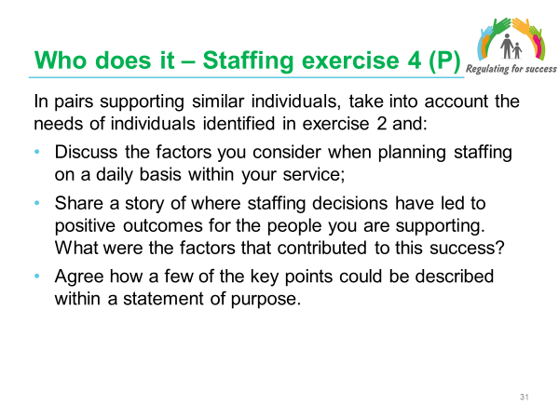

Facilitator Notes
- The purpose of this activity is to support providers to think about how they plan for the service.

- The intention is not to list the details of all individual staff members and their training and qualifications. This level of detail is not necessary apart from in relation to the manager and deputy and senior staff.

Facilitator Notes - Exercise

Ask the group to work in pairs and discuss the factors that they consider when allocating staff on a daily basis within the service (15 minutes).

- If possible, share a story of where staffing decisions have led to positive outcomes for the people you are supporting. What were the factors that contributed to this success? (10 minutes).

- As a whole group share and discuss what came up in the pairs discussion and identify what key points they would look to include in the Statement of Purpose (20 minutes).

- Share the case examples of Section 5 of the Statement of Purpose to illustrate how this section can be written.

Slide 32
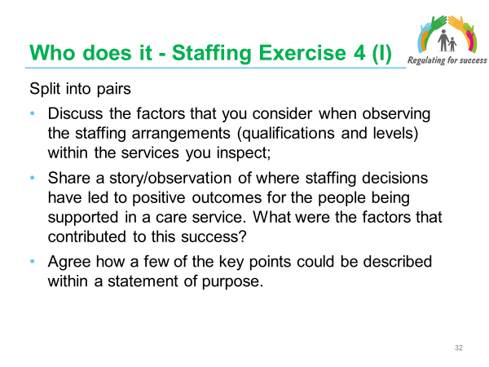

Facilitator Notes - Exercise
- Ask the group to work in pairs – discuss the factors that they consider when observing the allocation of staff within the services they inspect (15 minutes).

- If possible, share a story/observation of where staffing decisions have led to positive outcomes for the people supported. What were the factors that contributed to this success? (10 minutes).

- As a whole group share and discuss the key points they would want to see included in the Statement of Purpose (15 minutes).

- Share the case examples of Section 5 of the Statement of Purpose to illustrate how this section can be written.

Slide 33
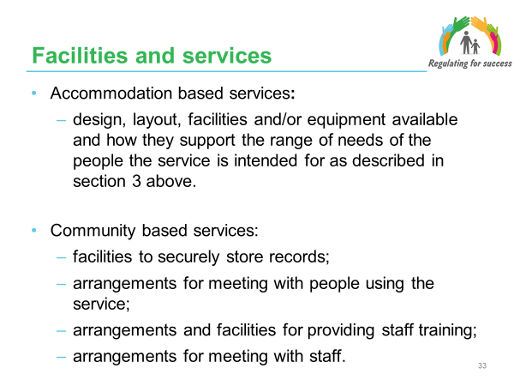

Facilitator Notes
- This slide covers the detail of the information required in Section 6 of the Statement of Purpose template.

- The Statement of Purpose must include details of the premises, facilities and equipment that will be available to individuals in accordance with the requirements of the regulations made under section 27 of the Act - the Regulated Services (Service Providers and Responsible Individuals) (Wales) and taking into account the range of needs set out in the statement of purpose.

- In the case of a care home service, a secure accommodation service or a residential family centre service, a description of the area in which the service is located and the community facilities and services available there. The detail needs to include a description of the unique or specific features about these.

- Reference needs to be made to the requirements of regulations 45 and 46 the Regulated Services (Service Providers and Responsible Individuals) (Wales) with regard to the use of single and shared rooms This includes both personal preferences and ratios.

- Note - this section does not apply to supported living arrangements.

Slide 34

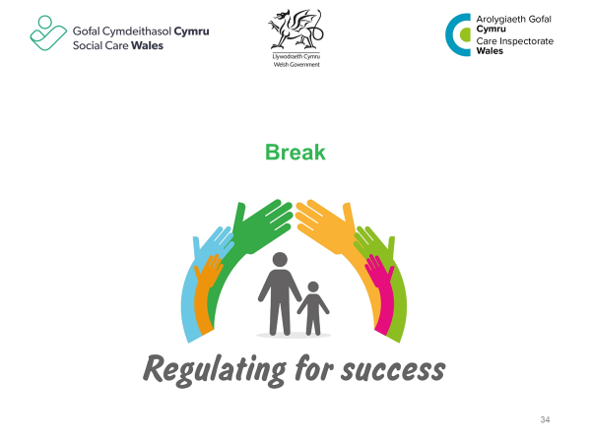

Slide 35
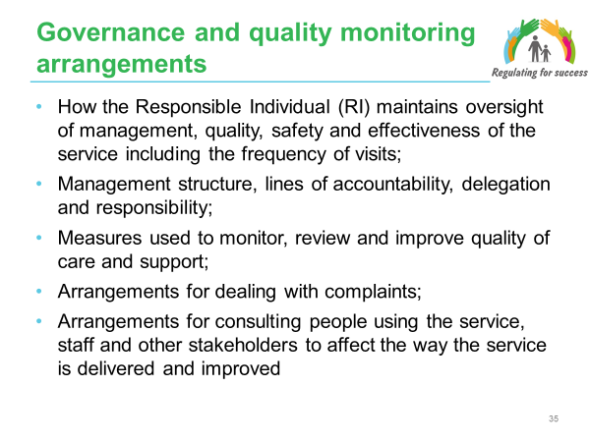

Facilitator Notes
- This slide covers the detail of the information required in Section 7 of the Statement of Purpose template.

- This section describes the oversight and governance arrangements to establish and maintain a culture that ensures the best possible outcomes for the individuals supported by the service.

- The Regulation and Inspection of Social Care Act rebalances accountability in the social care system, away from just those working on the frontline to ensure employers, company owners and directors are accountable in law.
- Providers need to think about how it is delivering the service in accordance with statutory requirements; delivering against the Statement of Purpose; and how it knows the culture and ethos of the service is in place in practice.

- The concept of a responsible individual (RI) is not a new one. However, prior to the Act it was not a specific regulatory requirement of a service provider’s registration.

The responsibilities of the RI include:
- creating a culture where impact of the service can be measured on well-being of the person receiving the care;
- quality of care in each service;
- content and accuracy of information in the provider’s annual return;
- appointment of a suitable and fit registered manager;
- arrangements for record keeping and notifications to CIW.

- In developing arrangements for consulting with people who use the service consideration needs to be given to how these arrangements have been ’co-produced’ and designed with the involvement of the individuals. It is also important to ensure that the arrangements put in place are appropriate for the range of needs the service is provided (engaging with other stakeholders may provide information to support this).

Slide 36
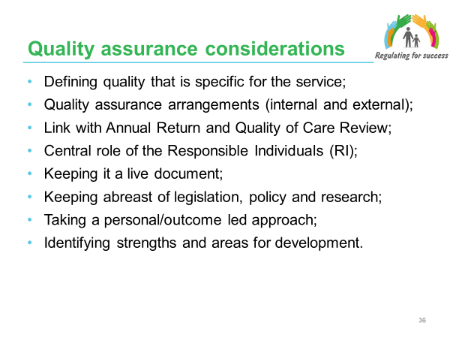

Facilitator Notes
Handout: Quality of Care Review AND Annual Returns
- Defining quality that is specific for the service - It is important that providers put in place a clear description of the quality standards that are expected within the service. Whilst some of these will be based on legislative requirements, they should also reflect the philosophy and aims of the service. It will be against this definition of quality that RI’s will be formulating a judgement of the quality of the service within the Quality of Care Reviews. In doing this clarity is also provides to staff about how they should be working with individuals and providing care and support and it also helps to clarify to individual and families what they can expect from the service.

- Quality assurance arrangements (internal and external) - Quality assurance arrangements that are put in place need to be fit for purpose for internal and external purposes.

Internally, the arrangements will provide assurances that the desired quality and performance standards are being achieved and that information is being collected for the quality of care review and annual return.

Externally, it will support continuous preparation for inspection and satisfying the requirements of commissioner and contractor specifications.

- Link with Annual Return and Quality of Care Review - The Regulation and Inspection of Social Care Act ensures for the first time that annual returns are prepared by all regulated providers of social care in Wales (statutory, private and third sector providers) so performance can be scrutinised and compared.
- All registered providers to prepare annual returns outlining their performance and how care improves well-being;
- Published on the CIW website alongside the inspection report;
- Addresses staff retention, training and development, complaints etc.

The Annual return will include:
- Elements relating to the provider;
- Information about each place.

Annual returns will provide greater transparency for people to compare services and choose those which are best for them. They will be published on the CIW website alongside the inspection report. There will be more transparency and comparable information about services and it will make it easier for people to make well-informed choices about their care and to take more control.

It is important to note that both the Quality of Care Review and Annual Return will be focussed on how well good quality services and personal outcomes for individuals are being achieved in line with the Statement of Purpose.

The aim is to move to a new relationship between regulator and providers, moving from compliance to one that drives up quality. Providers will be more accountable for their own standards and continuously improving their own quality and impact on their service users’ well-being.

- Central role of the Responsible Individuals (RI) – The Regulated Services (Service Providers and Responsible Individuals (Wales) Regulations require RIs to put suitable arrangements (processes) in place establish and maintain a system for monitoring, reviewing and improving the quality of care and support provided by the service. This must include a process for undertaking a review of quality of care as often as required but at least every six months. On completion of a review of the quality of care and support, the responsible individual must prepare a report to the service provider (the requirement to report does not apply where the service provider is an individual and the service regulator has agreed to the service provider managing the service in accordance with regulation [63](2).

The RI is required to undertake a minimum of quarterly visits to the service in person to monitor the performance of the service in relation to its statement of purpose and to inform the oversight and quality review. The visit includes the following:
- talking to, with consent and in private, individuals using the service and their representatives (if applicable) and staff. For domiciliary support services, this may include visiting a representative sample of individuals in their own home;
- inspecting the premises, a selection of records of events and any complaints records.

The RI is accountable for the quality and accuracy of the information provided in the statement of compliance with the requirements as to standards of care and support to be included in the service providers annual return.

- Keeping it a live document - The Statement of Purpose needs to be seen as a ‘live’ and working document and as such providers need to amend the Statement of Purpose before submitting a variation or where there are changes to the service or the way they provide it. Providers must provide the service in accordance with the statement of purpose and must:
(a) keep the statement of purpose under review, and
(b) where appropriate, revise the statement of purpose.

The statement of purpose needs to be reviewed and updated at least annually or when changes are being made to the service provided.

Providers must amend the statement of purpose when changes are made which result in it no longer accurately describing the service provided and/or how it is provided.

When significant changes to the service are going to be made there is a requirement to inform the regulator 28 days in advance of the proposed changes using the CIW online notification process. An amended statement of purpose will need to be submitted. The persons who must be notified of any revision to the statement of purpose (unless the change is being made with immediate effect) are:
(a) the service regulator,
(b) the individuals,
(c) the placing authority (where relevant), and
(d) any representative, unless it is not appropriate to do so or would be inconsistent with the well-being of an individual.

Examples of significant changes include:
- Where a service which does not provide nursing, care intends to provide nursing care;
- Provision of additional specialist services e.g. palliative care or acquired brain injury;
- Where a specific service referred to in the statement of purpose is to be withdrawn; or
- Changes to the normal staffing arrangements as described in section 5 of the statement of purpose.

CIW will consider the changes proposed and will need to be satisfied that:
a) The service will continue to make proper provision for the well-being of people using the service;
b) is able to meet the standards required by the regulations; and
c) does not constitute a change that requires an application for a variation of the registration.

- Keeping abreast of legislation, policy and research - It is essential that the staff and managers keep up to date with legislation and policy and that all those involved in the delivery of the service have a good understanding of new regulations, policy and guidance that relate to all aspects of meeting needs and achieving outcomes. This includes requirements placed under the Social Services and Well-being Act and Regulation and Inspection Acts in particular. It is also important that providers are up to date with the changes to workforce regulation and in particular changes to qualification and registration requirements.

Providers need to keep abreast of research about the needs (and fluctuating needs) of the individuals they support to ensure they continue to provide the most appropriate care and support services to meet these needs.

- Taking a personal/outcome led approach - With an increased emphasis on well-being and personal outcomes and on the quality of care that is provided, quality assurance arrangements need to place an emphasis on demonstrating the impact of care and support that is provided on individuals’ well-being and outcomes as much as they do on the effectiveness of systems and processes.

- Identifying strengths and areas for development - A balanced approach to the findings and reporting of quality assurance activities needs to be taken in order for strengths and successes to be identified and further enhanced and delivered in addition to the areas for development and issues that need to be fixed/ addressed.

Slide 37
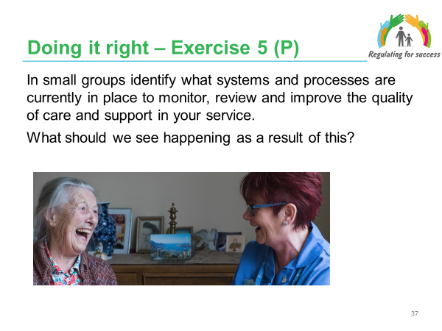

Facilitator Notes
The aim of this activity is to encourage providers to consider how they would know if the service is meeting the needs and outcomes of individuals, is providing the appropriate care and support to meet these needs and outcomes, that the right staff are in place to meet the needs of those receiving the service, that the services provided are of a good quality.

Facilitators Notes – Exercise
- In small groups (15 minutes) – Taking into account the elements of service provision that are described within your statement of purpose consider the processes and systems that are currently in place.
- Follow this with a discussion about what they would expect to see as a result of the information obtained through quality assurance activities. (15 minutes)
- Popcorn feedback (participants volunteer their responses) from the tables of one or two examples each
- Share the case examples of Section 7 of the Statement of Purpose to illustrate how this section can be written.

Facilitators Notes - Examples

Examples of activities may include:
- Monthly reports from designated/ senior staff such as: maintenance; catering; care; nursing; cleaning; administration – fed through to the RI for their reporting
- Quality monitoring tool
- Local authority/ Health contract monitoring arrangements
- Audits e.g. falls; pressure sores; case recording; medication and pharmacy
- Staff records
- Resident and relative meetings
- Analysis of complaints, compliments and feedback
- Board member meetings (larger organisations)
- Service user forums.
- Staff exit interviews
- Celebrating positives and learning from good practice

Examples of impact may include:
- people at all levels talking about what went well and what could be improved in an open and honest way
- fewer accidents and incidents
- cycles of reflection, learning and action
- improved outcomes for individuals etc.

Slide 38
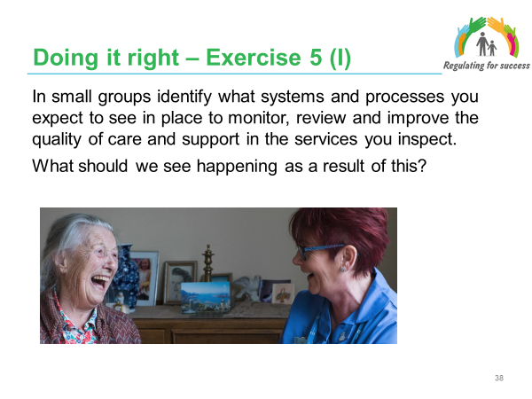

Facilitator Notes
The aim of this activity is to encourage inspectors to consider how they would know if the service is meeting the needs and outcomes of individuals, is providing the appropriate care and support to meet these needs and outcomes, that the right staff are in place to meet the needs of those receiving the service, that the services provided are of a good quality.

Facilitators Notes – Exercise
- In small groups identify what systems and processes you expect to see in place to monitor, review and improve the quality of care and support in the services you inspect. (15 minutes)
- Follow this with a discussion about what they would expect to see as a result of the information obtained through these quality assurance activities (15 minutes).
- Popcorn feedback (participants volunteer their responses) from the tables of one or two examples each.
- Share the case examples of Section 7 of the Statement of Purpose to illustrate how this section can be written.

Facilitators Notes - Examples

Examples of activities may include:
- Monthly reports from designated/ senior staff such as: maintenance, catering, care, nursing, cleaning, administration – fed through to the RI for their reporting;
- Quality monitoring tool;
- Local authority/ Health contract monitoring arrangements;
- Audits e.g. falls; pressure sores; case recording; medication and pharmacy;
- Staff records;
- Resident and relative meetings;
- Analysis of complaints, compliments and feedback;
- Board member meetings (larger organisations);
- Service user forums;
- Staff exit interviews;
- Celebrating positives and learning from good practice.

Examples of impact may include:
- people at all levels talking about what went well and what could be improved in an open and honest way;
- fewer accidents and incidents;
- cycles of reflection, learning and action;
- improved outcomes for individuals etc.

Slide 39
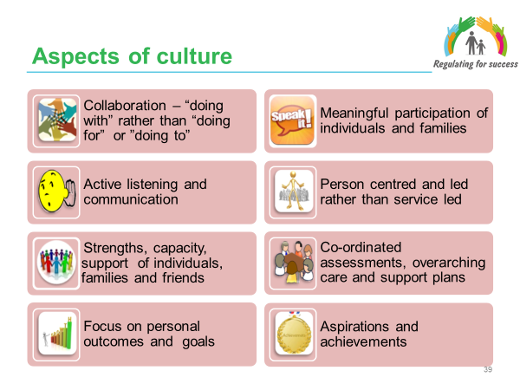

Facilitator Notes
Handout: Organisational culture
- These are the key features of the culture that is described and required through the new legislation (primarily through Social Services and Well-being Act but also inherent within the Regulation and Inspection Act). These are areas that have been addressed throughout the training.
- Providers are encouraged to consider these as they develop and review their services and describe these within the Statement of Purpose.

Facilitator Notes - Exercise
An optional exercise - As a whole group invite the group to identify which areas they think they are doing well and which areas require further development

Slide 40
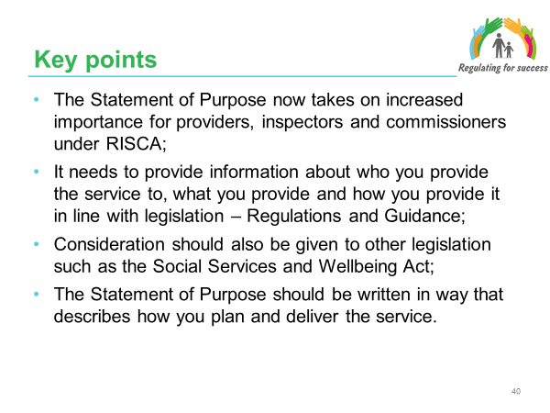

Facilitator Notes
- These next two slides summarise the key points.

- The Statement of Purpose is a key document and there are numerous references throughout legislation and guidance unlike before.

- Essentially it is about what and how without going into too much detail which would necessitate it being updated on a weekly basis (e.g. staffing). However, it does need to describe how the service will meet the needs and personal outcomes of the individuals the service says it can support. In many cases these might include quite specialist needs.

- It is important to emphasise the connections with the other legislation and supporting themes around well-being, co-production, etc. (emphasising the point in bullet two)

Slide 41

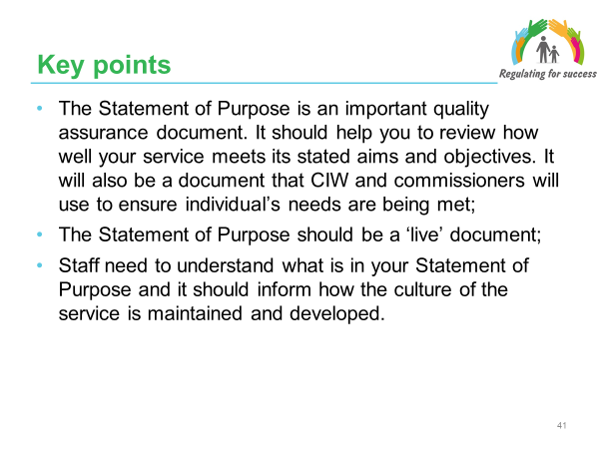

Facilitator Notes
- The quality assurance element is an important one. It acts as an external mechanism to allow others to know what the service says it can provide and how it is provided – but also to test this out. However, it also allows the service and its staff to reflect on strengths and whether the service is continuing to meet the organisations’ expectations – or maybe surpassing them?

- It is important to emphasise a key point and reminder that the old Statements of Purpose were rarely updated and that they now need continual review.

- If providers plan to change their service in a way that impacts on the Statement of Purpose they need to inform CIW at least 28 days in advance;

Slide 42
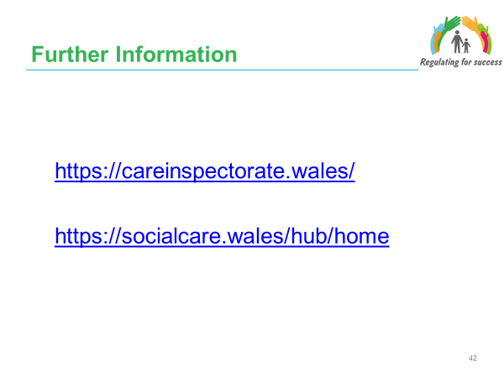

Facilitator Notes
- The Social Care Wales Information and Learning Hub has a wide range of information on the Social Services and Well-being Act and the Regulation and Inspection of Social Care Act including:
- Links to the legislation
- Welsh Government factsheets
- Technical briefings
- FAQ’s
- Learning resources

- The Care Inspectorate Wales website has information on the Regulation and Inspection of Social Care Act including guidance and advice.

Key Resources

Legislation, Regulations and Guidance
Social Services and Well-being (Wales) Act 2014. The Act reforms social services law; to make provision about improving the well-being outcomes for people who need care and support and carers who need support; to make provision about co-operation and partnership by public authorities with a view to improving the well-being of people; to make provision about complaints relating to social care and palliative care; and for connected purposes.

Future Generations (Wales) Act 2015. The Act makes provision requiring public bodies to do things in pursuit of the economic, social, environmental and cultural well-being of Wales in a way that accords with the sustainable development principle; to require public bodies to report on such action; to establish a Commissioner for Future Generations to advise and assist public bodies in doing things in accordance with this Act; to establish public services boards in local authority areas; to make provision requiring those boards to plan and take action in pursuit of economic, social, environmental and cultural well-being in their area; and for connected purposes.

Regulation and Inspection of Social Care (Wales) Act 2016. The Act makes provision for the registration and regulation of persons providing care home services, secure accommodation services, residential family centre services, adoption services, fostering services, adult placement services, advocacy services and domiciliary support services; amending the Social Services and Well-being (Wales) Act 2014 in connection with the regulation of the social services functions of local authorities; for the renaming of the Care Council for Wales as Social Care Wales; for Social Care Wales to provide advice and other assistance to persons providing services involving care and support; for the registration, regulation and training of social care workers; and for connected purposes.

The Regulated Services (Service Providers and Responsible Individuals) (Wales) Regulations 2017. These Regulations impose requirements on service providers in relation to a regulated service, including requirements as to the standard of care and support to be provided. The Regulations impose requirements on responsible individuals in relation to a place in respect of which the individual is designated. These Regulations also provide for offences in the event of failure by a service provider or a responsible individual to comply with specified requirements.

The Regulated Services (Annual Returns) (Wales) Regulations 2017. These Regulations prescribe the information about training and workforce planning and other information which must be contained in the annual return, to prescribe the form of the annual return and to prescribe the time limit within which the annual return must be submitted to Welsh Ministers.

The Regulated Services (Registration) (Wales) Regulations 2017. These Regulations prescribe the information that must be contained in an application for registration as a service provider of a regulated service and the processes that are required to be followed.

Statutory guidance for service providers and responsible individuals on meeting service standard regulations (2017). Issued by Welsh Government to set out:
  - how providers of regulated services may comply with the requirements imposed by the regulations made under section 27 of the Act, and
  - how persons designated as a responsible individual for a regulated service may comply with the requirements imposed by the regulations made under section 28 of the Act.

Additional resources
Care and Social Services Inspectorate Wales (2018) ‘A guide for compiling a Statement of Purpose’

Care and Social Services Inspectorate Wales (2017) ‘Regulation and Inspection of Social Care (Wales) Act 2016 – Re-registration guidance for providers’

Social Care Wales (2018) ‘Information and learning resource for Responsible Individuals’

Contact Details

Social Care Wales
South Gate House
Wood Street
Cardiff
CF10 1EW

Tel: 0300 3033 444
Fax: 029 2038 4764
Minicom: 029 2078 0680

E-mail: xxxxxxxxxxxxxxx
Website: xxxxxxxxxxxxxxxxx

It is expressly prohibited to use any, or all, of this training resource for commercial gain.

Further copies and other formats:
This publication is also available in other versions, including as a pdf. Further copies of this document and other Social Care Wales resources about the Social Services and Well-being (Wales) Act are available to download from the Information and Learning Hub

