SOCIAL SERVICES AND WELLBEING (WALES) ACT
HANDOUT

Legislative Duties
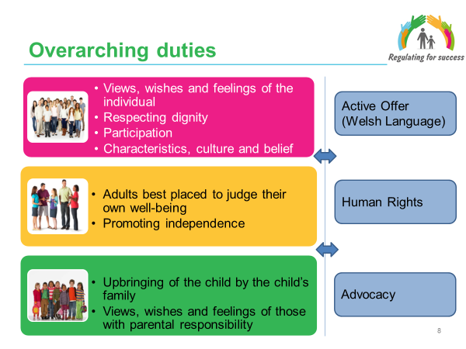

1. Overarching Duties
1.1 The following sections under Part 2 of the Social Services and Well-being
(Wales) Act 2014 set out key duties on local authorities in the delivery of care and support services:
• Section 5 - sets out how local authorities should ensure they meet their
duty to seek to promote the well-being of people who need care and support
and carers who need support
• Section 6 – sets out how local authorities should comply with the general
overarching duties set out in the Act; and
• Section 7 – sets out how local authorities should comply with other
overarching duties set out in the Act: UN Principles and Conventions.

There are no regulations made under these sections,

1.2 These duties apply to local authorities (or other organisations the local authority has discharged/ delegated functions to – such as commissioned/ contracted services) and their practitioners when working with a person who may have needs for care and support or a carer with support needs, even if it has not been established that the individual has such needs or if those needs would be eligible.

1.3 Four of these overarching duties apply in all cases, whether an adult or a child. The duty to:
- Ascertain and have regard to the individual’s views, wishes and feelings, in so far as is reasonable practicable.
- Have regard to the importance of promoting and respecting the dignity of the individual.
- Have regard to the importance of providing appropriate support to enable the individual to participate in decisions that affect them to the extent that it is appropriate in the circumstances, particularly where the individual’s communication is limited for any reason.
- Have regard to the characteristics, culture and beliefs of an individual, including language
In the context of these overarching duties a requirement to ‘have regard’ to a particular matter is similar to a requirement to ‘consider’ or ‘take into account’ that matter

  - Two overarching duties apply specifically to adults:
- to begin with the presumption that the adult is best placed to judge their own well-being
- to have regard to the importance of promoting their independence where possible.

  - In relation to children there is also the duty to:
- promote the upbringing of the child by the child’s family, in so far as doing so is consistent with the well-being of the child
- for under 16s, to ascertain and have regard to the views, wishes and feelings of those with parental responsibility, in so far as is practical and consistent with the child’s well-being

  - The overarching duty to have regard to the characteristics, culture and beliefs
of an individual reinforces existing legislation and guidance for anyone in Wales to be able to live their lives through the medium of Welsh if they choose to do so. This means that peoples’ cultural identity and language needs must be at the heart of care and support because it is an essential element to good quality care and high professional standards.

2. Active Offer (Welsh Language)

  - “More than Just Words....” a strategic framework for Welsh language services
in health and social services provides a systematic approach to improve services for those who need or choose to receive their care and support in Welsh. The aim of the framework is to ensure that organisations and practitioners recognise that language is an intrinsic part of care and support, and that people who need services in Welsh get offered them. This is called the ‘Active Offer’ and means moving the responsibility from the person to ask for services through the medium of Welsh, to the service which must ensure it provides them.

3. Human Rights

3.1 The overarching duties also include human rights. A key part of practitioners’ roles under the Act is to empower people through helping them to assert these rights. This is a key change. While some local authorities and organisations have been voluntarily respecting and delivering human rights in their work, from April 2016, a person exercising functions under the Act will be required to demonstrate ‘due regard’ to the UN conventions.

  - A person exercising functions under this Act in relation to an adult must have
due regard to the United Nations Principles for Older Persons.

  - A person exercising functions under this Act in relation to a child must have
due regard to the United Nations Convention on the Rights of the Child (UNCRC).

  - A person exercising functions under this Act in relation to disabled adults or
children must have due regard to the United Nations Convention on the Rights of Disabled People (UNCRDP). This includes:

  - The Code of Practice for Part 2 of the Act also makes it clear that public
authorities must not act in a way that is incompatible with rights under the European Convention of Human Rights. This includes:
- Article 2 – right to have life protected
- Article 3 – right not to be subjected to inhuman or degrading treatment
- Article 5 – right to liberty and security
- Article 6 – right to a fair hearing
- Article 8 – right to respect for private and family life, home, and correspondence

4. Advocacy

4.1 The Act requires that local authorities support people to fully participate in
decisions made about their care and support. People should be active partners in the key care and support processes of assessment, care and support planning and review, and any safeguarding enquiries. Despite the barriers individuals may be experiencing, local authorities must involve them, help them express their wishes and feelings, and support them to weigh up options and make decisions about their personal outcomes.
4.2 A judgement must be made, in partnership with the adult or child / their family, about whether that individual can only overcome the barrier(s) and participate fully if there is someone available to support and represent their views, wishes and feelings. If there is no ‘appropriate individual’ to advocate for the person an independent professional advocate must be arranged to support and represent them.

4.3 An ‘appropriate individual’ could be a parent, carer, friend, neighbour or
relative. The key thing is that they must be able to adequately support the person’s participation. They must not be someone the person does not want to support them nor someone implicated in a safeguarding enquiry.

4.4 If an adult or child aged 16 or 17 lacks capacity to make a decision then an assessment of their capacity under the Mental Capacity Act 2005 should be made. This may affect the type of independent advocacy which is appropriate to be provided for them.

PRACTICE NOTE: It is important to recognise that these duties should be implicit within the culture, practices, procedures of organisations and the competencies, skills and expertise of our staff. As such they need to be considered when developing the Statement of Purpose.

