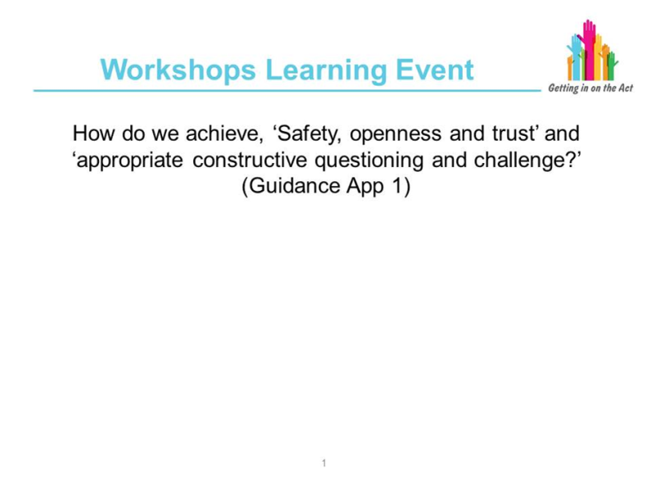
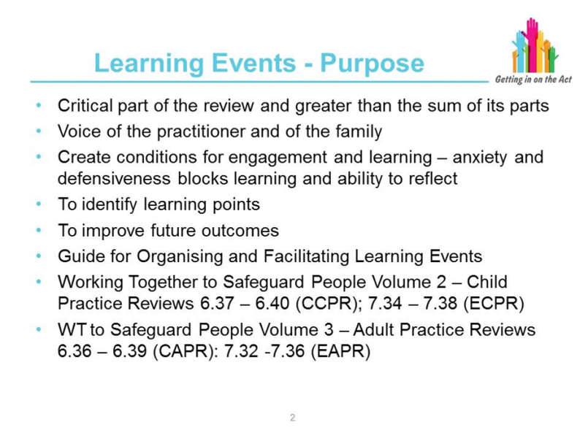
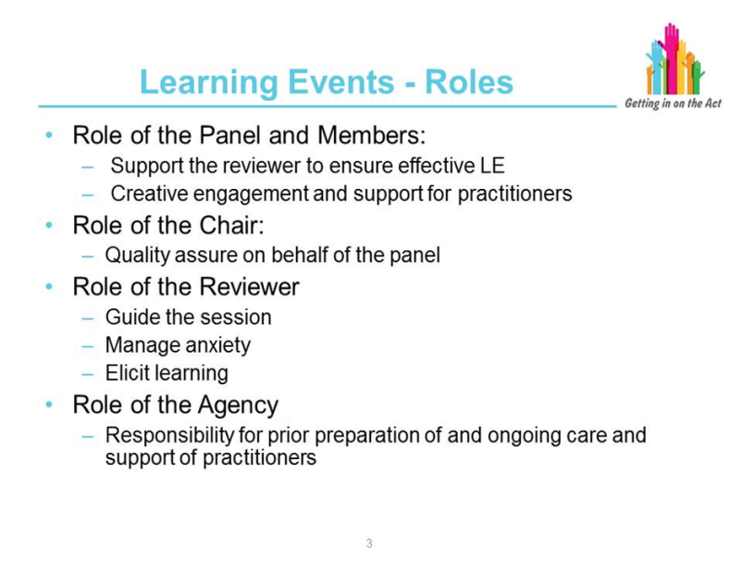

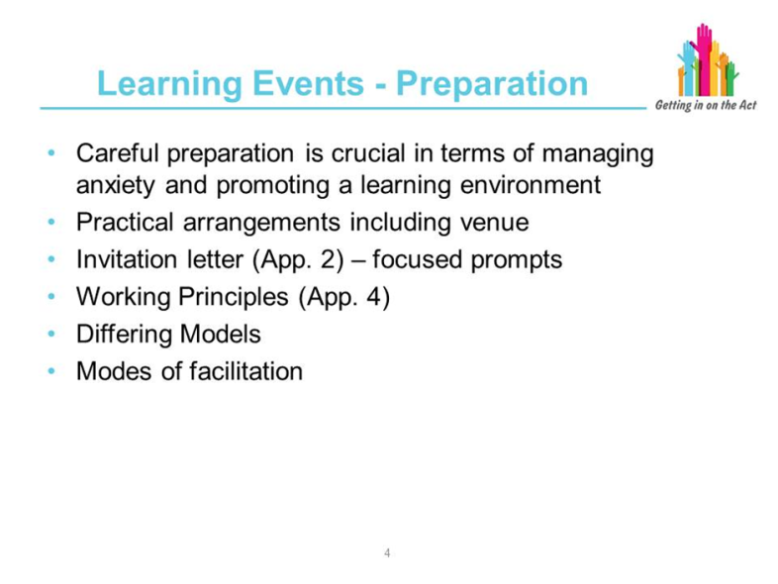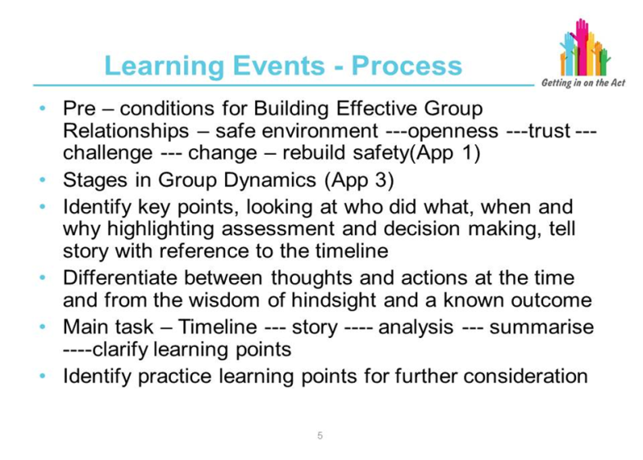

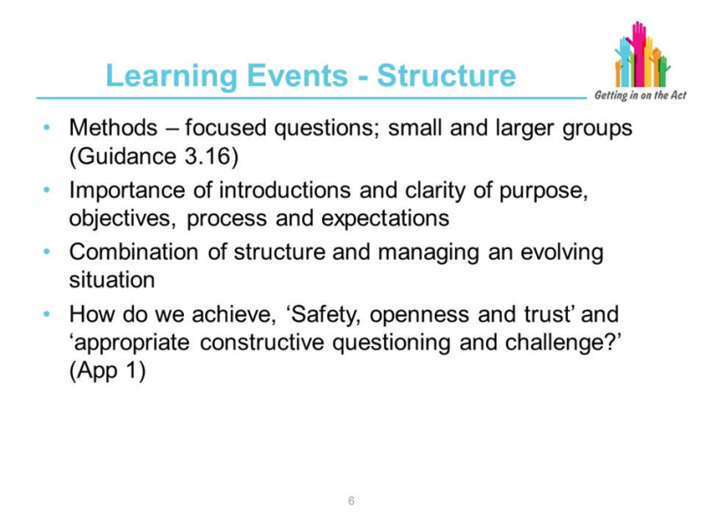

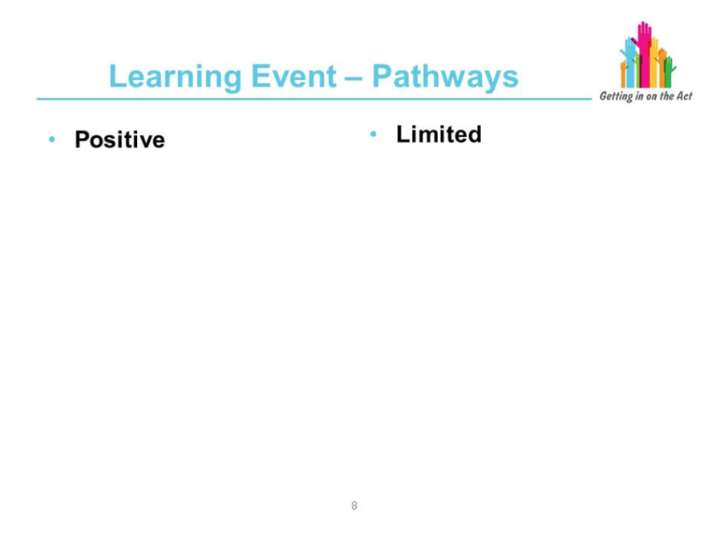
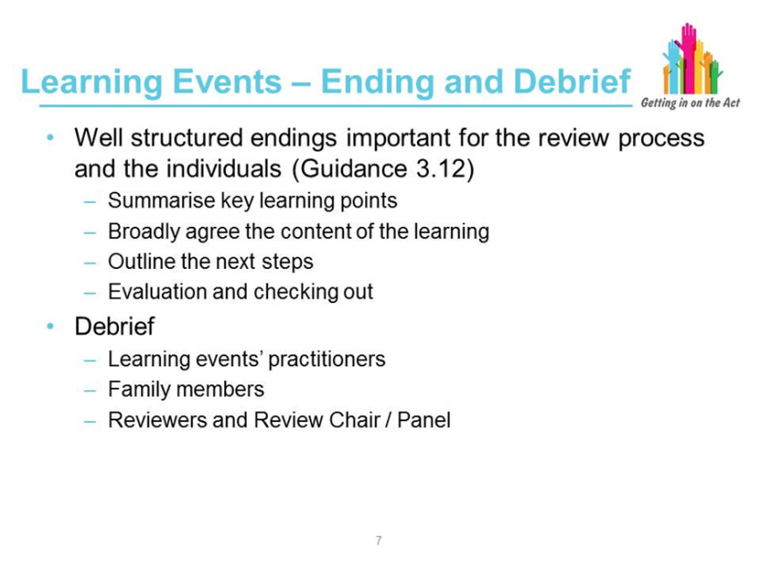

Slides which are self-explanatory and focus on a question taken from the Learning Event Good Practice Guide:

How do we achieve ‘Safety, openness and trust’ and ‘appropriate constructive questioning and challenge’? (Guidance App 1)

To be delivered alongside flipchart papers on display:

List of Appendices 1-6 from the guidance.

Utilise suggested model of convening Learning Event and replicate on flipchart (found to be effective in eliciting discussion):
- Introduction and Reflection (using merged Timeline describe on a chronological basis individual involvement in the case; ask participants to contribute and to begin to note emerging issues and any learning points).
- Story – Analysis (ask attendees in multi-agency pairs to physically move around the Timeline placed on the walls to identify significant events. Apply hindsight and consider the actions taken – Why did we do that then? Could we have done it differently and would it have helped? What did we do well? Consider the views of those not there eg, family members).
- Summarising – Clarifying (reviewer summarises – matters covered; matters that have emerged; check out individuals’ thoughts).
- Concluding and Evaluation (large group discussion and translate into action points; evaluate the experience and confirm ongoing support provision).

Reference to the identified merits of the Learning Event model according to the comparative SCR practice review analysis:
- identifying critical event
- demonstration of co-production in learning (Well-being Act principle)
- individual and agency critical analysis and reflection
- opportunity for learning and continuous professional development
- opportunity for agency learning and improving outcomes.

Suggest group activities to consider:

How do we achieve ‘Safety, openness and trust’ and ‘appropriate constructive questioning and challenge’? (Guidance App 1)

Group activity to plan a Learning Event, giving particular consideration to:
- the preparation and support needs of attendees, including the potentially emotive impact of visual aids such as the Timeline and/or use of photographs
- support provision and contingencies during and following the event
- parallel processes and any potential implications (CPS/Police Liaison Guidance)
- how the views of family members are going to be conveyed and addressed
- how the Panel are to be involved – usually the Chair will attend.

