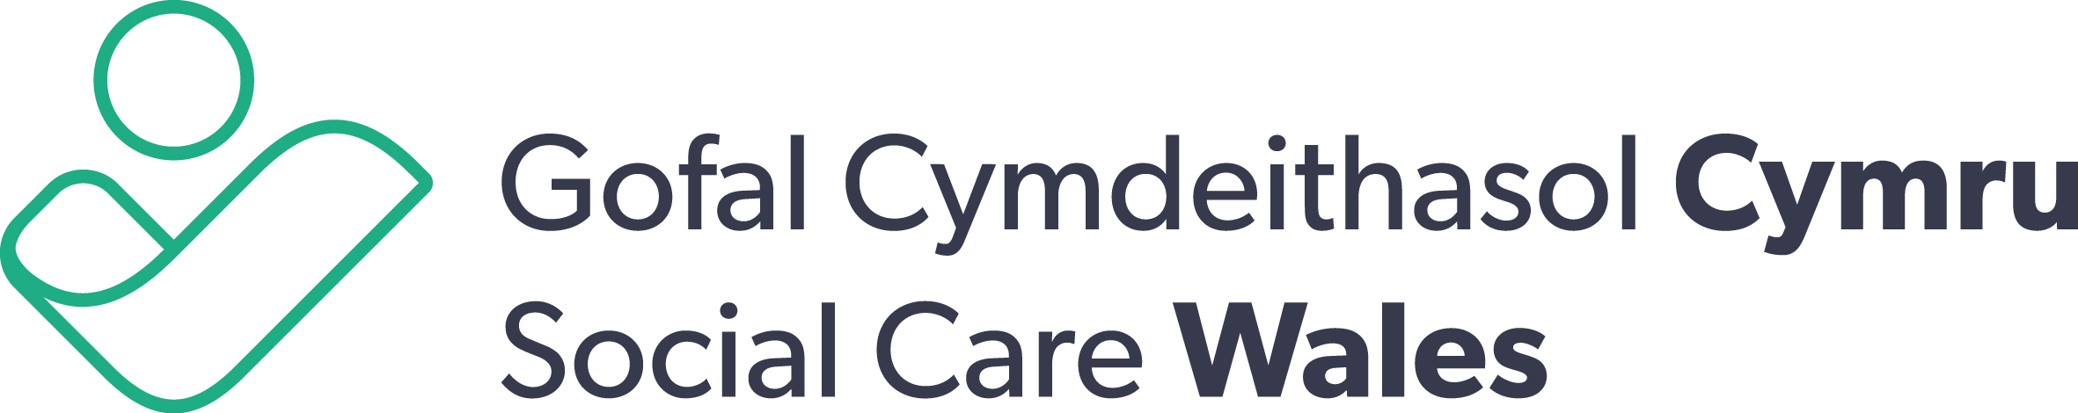
SOCIAL SERVICES AND WELL-BEING (WALES) ACT 2014

Assessment & Eligibility Case Study
Nathan and Gwen Davies – Part 1
A learning and development resource for direct
care and support workers on the Social Services
and Well-being (Wales) Act 2014

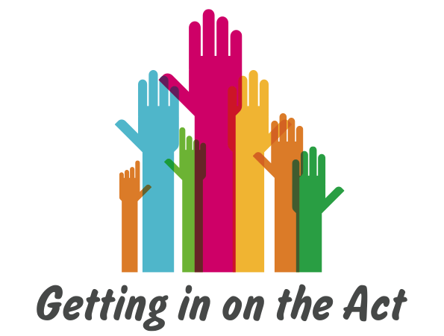

Children’s Case Study: Nathan and Gwen Davies (Part 1)
This case study supports practitioners to undertake assessment and determine eligibility as part of their duties under the 2014 Act. In the longer term, the Welsh Government will support ADSS Cymru to develop a single assessment tool, in line with the Welsh Community Care Information System (WCCIS). It has been designed for use in any of the following settings:
- As a prompt for individual reflection
- Supervision sessions
- Peer support sessions
- Practice learning meetings
- Team meetings
- Formal training and learning events
To make the best use of this study, please take the time to consider the three ‘pause and reflect’ points that appear within the document.
To access more case study examples, click here. To access the national assessment and eligibility tool, click here.
Before you begin…
Here is a reminder of the 4 conditions for eligibility. They are:
- Needs arising from the person’s circumstances due to - physical or mental ill-health; age; disability; dependence on alcohol or drugs or similar circumstances.
- Needs related to outcomes described in the regulations - self-care and domestic routines; communication; protection from abuse or neglect; involvement in work, education, learning or in leisure activities; family or personal relationships; involvement in social relationships and the community; caring responsibilities of a child.
- Person is not able to meet their needs either by themselves, or with care and support from others, or by assistance from the community.
- Person is not able to achieve one or more of their outcomes, unless the local authority provides or arranges a care and support plan, or provides direct payments to the person
to arrange their own care and support.
IMPORTANT
An individual’s pathway to care and support will be determined by your Authority’s local arrangements. These case studies support practitioners to implement consistently their duties to undertake assessment and determine eligibility as part of their wider duties under the 2014 Act. They form part of the national assessment and eligibility tool.
The determination of the person’s eligibility is separate from any financial assessment that the local authority is required to make about any potential contribution by an adult to the cost of care and support provided. The Act prevents local authorities from charging a child for the care and support they receive, or for support provided to a child who is a carer.

The person must feel they are an equal partner in their relationship with professionals and can invite someone of their choice to support them to participate fully and express their views, wishes and feelings. This support can be provided by friends, family or wider support network.
The Social Services and Well-being (Wales) Act 2014 Part 10 Code of Practice (Advocacy) specifies the circumstances when a local authority must arrange an independent professional advocate to support that person.
Children’s Case Study: Nathan and Gwen Davies
Part One
1st March 2017

Gwen Davies contacts the Local Authority Information Advice and Assistance (IAA)Service

“I’m ringing you to get more information about the Child and Adolescent Mental Health Service (CAMHS) in the area. We’ve recently moved here and my son, Nathan, previously accessed the service where we used to live. Can you give me the contact details, please?”

Mrs Davies provides no further information at this stage and states that she just requires information. She is provided with the contact telephone number for CAMHS, and details of the Family Information Service so that she can access information about other services in the area.

16th March 2017
Gwen Davies visits the Local Authority IAA Service.

“I phoned you two weeks ago to obtain information on the CAHMS. Today I got a letter from them to say there’s a 12-month waiting list. My son’s behaviour is getting worse. He’s starting to get aggressive with me and Charlie, and I’m starting to feel like I can’t cope anymore. Is there anyone who can help me?”

September 2017
Reason for intervention:
Self-referral for assistance to manage her son’s behavioural needs
National Minimum Core Data Set completed including the following:
- Consideration of mental capacity, Deprivation Of Liberty Safeguards(DOLS) and advocacy
- Safeguarding issues
- Active offer of the Welsh language
Welsh is Gwen’s first language and any discussions, assessments and meetings should be conducted in Welsh. All written information and copies of assessments should also be in Welsh.
1. Pause and reflect
Before looking at the Assessment of Needs, how would you identify ‘what matters’ to the individual in this situation?
What is helping the individual and what is stopping them achieve their well-being outcomes?
Assessment of needs
“What matters” to Gwen?
- Personal circumstances:
Gwen has recently moved to the area with her two children. Nathan is 11 and her daughter, Charlie, is 17.

Although she has a family network, they live in another part of Wales. Gwen and her children live in a private rented house. Previously, Gwen enjoyed going to keep fit classes, had a part-time job in a local shop and a small group of friends. However, since the move she hasn’t managed to establish a new social network and is currently unemployed.

Nathan is enrolled in the local Welsh Medium Primary School, Ysgol Gymraeg Dewi Sant. Nathan doesn’t like going to school, and can be difficult to motivate in the morning. However, once he gets to school, he’s fine. Gwen has had no reports from the school about Nathan being aggressive or misbehaving.

“When he gets home from school, it’s a different story. He told me he behaved all day in school, so he can’t hold it in anymore when he gets home.”

Gwen said that she is finding it difficult to cope with Nathan and is worried about how his aggressive behaviour is affecting Charlie and herself. He shouts at them and throws things around the house.

“So far, he hasn’t hit either of us on purpose, but I’m worried that if his behaviour keeps getting worse, he will hit out. Charlie is a help, but Nathan doesn’t like Charlie telling him what to do.”

Gwen has been diagnosed with Fibromyalgia. This can affect Gwen’s energy levels, and she sometimes has difficulty waking up in the morning. On those days, Charlie helps Nathan get ready for school in the morning.

“I don’t know how I’d cope without Charlie, she’s as good as gold.”

Nathan has told Gwen he wants help, like he had from Pete, the CAMHS employee who worked with Nathan prior to the family moving.

Input from other professionals?
Other than Nathan’s school, there is no current input from other professionals. Gwen tried to seek support from CAMHS, but was told that there would be a 12-month waiting list. Gwen Davies confirmed that there was no input from social services in the family’s previous home area.

2.Personal outcomes:
Gwen’s outcomes for Nathan | National well-being outcomes
- I want Nathan to have the help he needs. | - I get the right care and support, as early as possible.  - I know and understand what care, support and opportunities are available and use these to help.

3.Strengths:
- Gwen recognises that she is having difficulties and is seeking support.
- Charlie provides support to her mother in caring for Nathan.
- Nathan seems to have settled in school, and Gwen has had no reports from school about his behaviour.
- Gwen clearly loves Nathan.
4. Barriers:
- The family are new to the area, so there is a lack of knowledge about the support available to address Nathan’s behaviour.
- Gwen’s physical well-being fluctuates as a result of her illness, so she may not have the resilience to meet Nathan’s needs without support.
- Nathan and his family are socially isolated, with no local support networks.
5.Risks
- Any progress Nathan made with CAMHS in his previous home area is at risk, because there has been no seamless transition to CAMHS in his new home area.
- Nathan could hurt his mother or sister if his aggression increases.

2. Pause and reflect
Before looking at the Assessor’s Analysis, consider what alternative, non-statutory local authority services would help the individual achieve their well-being outcomes?
How would you help them meet their well-being outcomes?

Assessor’s analysis
Overview
Gwen Davies and her family have recently moved into the area from another part of Wales. They have no support networks or family in the area. Gwen has been diagnosed with Ffibromyalgia and is taking medication prescribed by her GP. When her condition deteriorates, it can impact on Gwen’s ability to provide for Nathan’s basic care needs.
The primary reason for Gwen contacting the local authority is to seek support to address her son’s behaviour. Nathan is said to have been receiving support from CAMHS in the family’s previous home area. Gwen contacted the local CAMHS, but has been advised that there is a 12-month waiting list. She believes Nathan’s behaviour is escalating, and needs more timely support.
Gwen reports that Nathan has settled into school and his aggressive behaviour appears to be limited to the home environment.
From the information gathered, Nathan’s needs as described by his mother can be met through the provision of preventative services, as set out within the families first objectives:
- Children, young people and families are healthy, safe and enjoy well-being.
- Families are confident, nurturing, and resilient.
Having provided Gwen Davies with information on the Families First Service, Mrs. Davies agreed that she was confident to make a self-referral, in order to receive parenting support, and assistance to access community services/groups that may benefit the family.
Identification of needs and determination of eligibility
The following analysis details whether Nathan meets the eligibility criteria for care and support from the local authority. The four points listed under each need consider the four stages to determining eligibility, as set out in the regulations.
1. To support Nathan’s well-being, Nathan and his family need to receive the right kind of intervention, as early as possible.

- Nathan’s need for intervention does not arise from his mother’s physical ill health.
- Nathan’s behaviour could impact on his relationships with his mother and sister, without intervention.
- Nathan and his family have limited support from within their community, and no family in the locality. However, Gwen has consented to a referral being made to Families First, to enable Nathan and his family to receive support from services within the community.
- Gwen can be supported to achieve her personal outcome for Nathan to receive the help he needs without the need for a care and support plan, through the provision of early intervention services.

This need is not eligible for a care and support plan from the local authority. The Information Advice and Assistance (IAA) Service will make a referral to Families First, with Gwen’s consent. It will be the responsibility of the Families First service to coordinate multi-agency, early intervention to address this need.

3. Pause and reflect
- How do the well-being outcomes match the ones you identified?
- Is the determination of eligibility provided in the case study consistent with your view of the case?
- What have you learned about identifying well-being outcomes and applying the eligibility criteria? What might you do differently because of this case study?

