Equal Pay Review Report
March 2019

- Context

  - The purpose of the equal pay review is to identify if there are any actual or potential inequalities relating to pay within the organisation, and if there are any, to act to address these.

  - In particular, we want to check that we are not directly or indirectly discriminating against any employee or group of employees through our pay systems.

  - The audit covers the 9 protected characteristics as identified by the Equalities Act 2010. These are:

- Sex
- Age
- Disability
- Race
- Gender reassignment
- Pregnancy or maternity
- Religion or belief
- Sexual orientation
- Marriage and civil partnership

- Objectives of the review

  - The objectives of the review are to:

- Make sure our pay systems are transparent
- Make sure that employees receive equal pay for equal work
- Identify and explain the reasons for any pay differences
- Identify and report on our gender pay ga

- Gender pay gap

3.1 Since April 2017, organisations with more than 250 employees have been required to publish their gender pay gap. Although we don’t fall under the scope of this legislation as we have less than 250 employees, we feel it is good practice to include gender pay data as part of our equal pay audit.

  - At March 2019 our Gender Pay Gap is 15.58%. This is a slight improvement
from January 2018 when it was 16.46%.

3.3 The National average (UK) currently sits at 18.4%. The public sector
average is 14.2%.

  - When we look at the breakdown in quartiles we see that although women occupy 65 per cent of the roles on the higher quartile, they also occupy 84 per cent of the lower quartile.

  - It is worth noting however that there has been a shift in the right direction over the past 12 months, as women previously made up 91.3 per cent of the lower quartile.
Pay quartiles
(How many men and women are in each quartile of our payroll)
Top quartile
Men | 35%
Women | 65%
Upper middle quartile
Men | 35%
Women | 65%
Lower middle quartile
Men
Women | 29%
 | 71%
Lower quartile
Men | 16%
Women | 84%

- Equal pay
Equivalent work
4.1 We compared the salaries for men and women on each pay grade within the organisation. As in previous years, we deemed this to be the best way to compare “like for like” work.
4.2 The graphs below show the salaries for men and women on each grade, and the length of time they have been on that grade.
4.3 The points on the graph may represent more than one person where they overlap. The table in appendix 2 shows the exact numbers.
4.4 It is usual practice in Social Care Wales to appoint new employees to the first (minimum) point of the relevant pay grade.

4.5 Exceptions to this may include situations where:
- An existing staff member is promoted to a higher-grade role within the organisation and there is an overlap in salary bands;
- A staff member has joined the organisation under TUPE arrangements, whereby their transferring salary is honoured.;
- We have experienced difficulties in attracting and recruiting applicants to a post at the bottom end of the advertised range, resulting in a negotiation of the starting salary.
4.6 In general, we would expect to see salaries increase with length of service, regardless of gender.

Analysis by grade

A1: Analysis  In A1 there are 18 women in post and 3 men. Last year’s ratio was 13:0.  The salaries reflect length in service. | 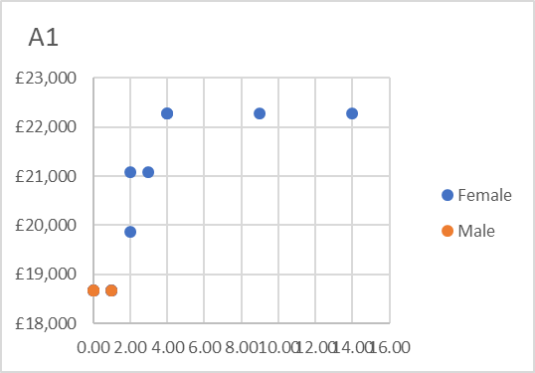
A2: Analysis  In A2 there are 19 women and 6 men.  The salaries reflect length in service, with two exceptions:  One female was appointed to the top of the scale. This was a post we found it difficult to recruit to, only receiving one application from a candidate who had a vast amount of knowledge and experience. A decision was therefore taken to appoint at top of scale.  Another female employee who was previously at the top of the A1 scale and moved to an A2 post was placed on a higher point due to the salary scales overlap. | 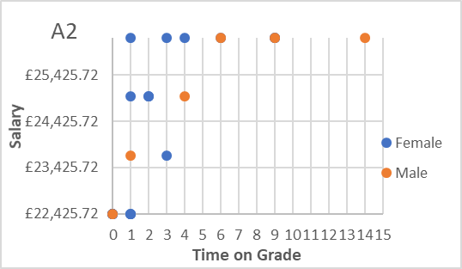
A3: Analysis  In A3 there are twelve women and five men in post.  For the women in post, the pay is in line with length of service.  The following should be noted in relation to male employees:  - One male employee started on the third point of the scale. This was negotiated and agreed based on his salary in a previous role / organisation.  - One male employees post was re-graded as a result of a job evaluation and placed at a higher point as he was already at the maximum point of A2.  - One male employee was appointed to an A3 role at a higher point as he was already at the maximum point of A2. | 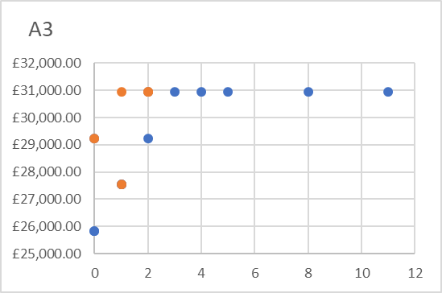
B1 Analysis:  In B1 there are 12 women and 8 men.  Salaries are consistent with length of service with three exceptions:  One female employee was appointed to the top of scale. This was a post that was re-advertised having not recruited on the first occasion. The second occasion drew only a small number of applicants with the preferred candidate moving from a role that carried a higher salary than our top of scale point. A decision was taken to appoint to top of scale for these reasons.  One female employees’ role was re-evaluated following a request through our job evaluation scheme. The post holder was already at the maximum point of A3, and the job evaluation was backdated by a year. She was therefore placed on the third point of B1.  One male employee was appointed to the second point of the B1 scale having moved from an A3 role. | 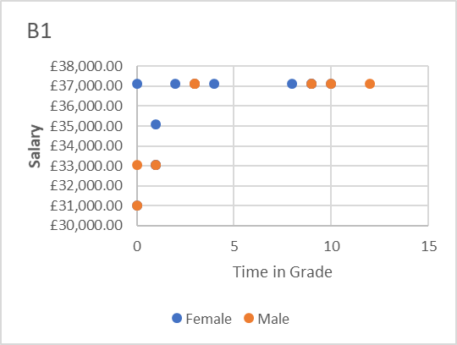
B2 Analysis:  In B2 there are 13 women and 4 men.  Two male employees were appointed to the third point of B2.  Both were moving from roles in other organisations that carried a higher salary than the third point. The third point salary was negotiated and agreed. | 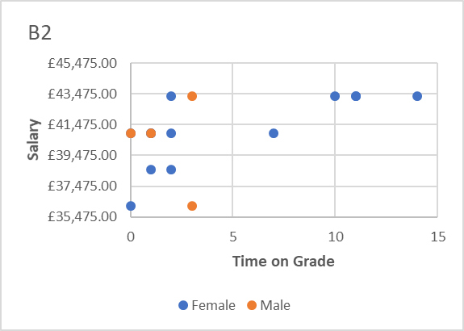
C1 Analysis:  In C1 there are 9 women and 6 men.  Salaries are consistent with length of service, with the exception of one female who was appointed to top of scale.  Her salary in her previous role at another organisation was just below our top of scale amount. | 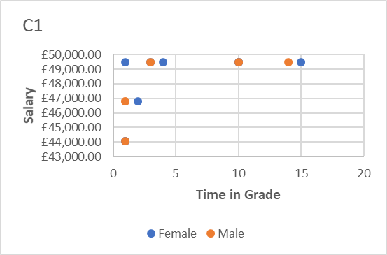
C2 Analysis:  In C2 there are 3 women and 3 men.  One female employee counted here was transferred on a TUPE arrangement at a pay rate that sits above our top of scale point. | 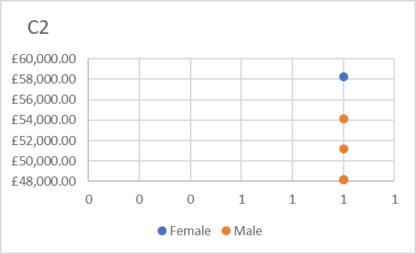

D Analysis:  In D, there are two women and one man in post. All three employees are at the top of the salary scale.  The increased salary for the male employee is a reflection of an ongoing salary supplement for additional responsibilities as a deputy chief executive. This comes to an end on 31 March 2019 | 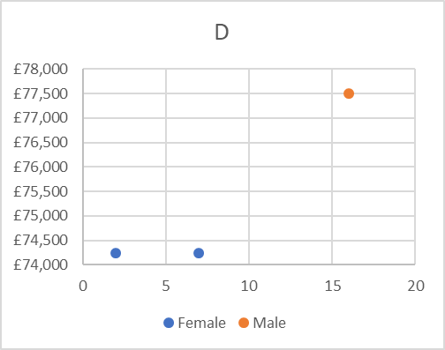

- Average salaries per grade

5.1 The average salaries per grade are as follows:
Grade | Average male salary | Average female salary | Variation
CEO | n/a | 113,333 | -
D | 77,509 | 74,249 | +4.2% (male)
C2 | 51,167 | 53,529 | + 4.6% (female)
C1 | 47,688 | 47,990 | + 0.6% (female)
B2 | 40,345 | 41,123 | + 1.9% (female)
B1 | 35,342 | 35,766 | +1.2% (female)
A3 | 29,923 | 29,243 | + 2.3% (male)
A2 | 24,956 | 23,107 | + 7.5% (male)
A1 | 18,673 | 19,741 | +5.7% (female)

5.2 The Equality and Human Rights Commission suggests that variations of five per cent or more should merit further investigation.
5.3 The figures show that we are above the tolerance rate in the A2 and A1 grades. Upon further investigation we note that the variation is in line with length of service within those roles.

- Other protected characteristics
Age
6.1 The average pay by age table shows that salaries tend to increase by age within the organisation. This is not unexpected given that our pay progression is incremental and linked length of service.
6.2 According to the ONS, the general trend across UK employers usually see’s average salaries begin to fall from age 50+. This is not the trend here, with more older employees occupying the higher grades.

 | Social Care Wales
Age | Male | Female
18-21 | n/a | £18,673
22-29 | £18,673 | £22,280
30-39 | £32,562 | £30,669
40-49 | £36,463 | £41,447
50-59 | £45,863 | £43,657
60+ | £52,957 | £113,333

Disability

6.3 4.8% of our workforce have declared a disability, and their salaries are consistent with length of service in grade. There is no evidence to show that employees are paid differently based on them having a disability.

Race

6.4 59% of the workforce have declared their ethnicity. Of these, 56% identified as White or White-Welsh and 3.2% as Black African, Black Caribbean and White Asian. There is no evidence to show that employees are paid differently based on their race.

Religion or belief

6.5 38.4% of employees have not declared their religion / belief. From those that have, there is no evidence to show that employees are paid differently based on their religion or belief.
Sexual orientation
6.6 39% of employees have not declared their sexual orientation. From those that have, there is no evidence to show that employees are paid differently based on their sexual orientation
Marriage and civil partnership
6.7 There is no evidence to show that employees are paid differently based on their marital status

Pregnancy or maternity
6.8 At the time of the report 2.4% of our workforce was pregnant or on maternity leave. Our increment policy ensures that staff continue to receive their annual pay increments while on maternity leave. This ensures that there is no negative impact on pay for employees who are on maternity leave.

Gender reassignment
6.9 As no employees have declared gender reassignment no comparative data is available.

Appendix 1

 |  | Number of staff on each point
Scale  Point | Salary | Female | Male
A1.1 | £18,673.14 | 11 | 3
A1.2 | £19,874.70 | 1 | 0
A1.3 | £21,076.26 | 3 | 0
A1.4 | £22,276.80 | 3 | 0
A2.1 | £22,425.72 | 9 | 1
A2.2 | £23,690.52 | 1 | 1
A2.3 | £24,955.32 | 3 | 1
A2.4 | £26,221.14 | 6 | 3
A3.1 | £25,843.74 | 2 | 0
A3.2 | £27,543.06 | 2 | 1
A3.3 | £29,243.40 | 2 | 1
A3.4 | £30,942.72 | 6 | 3
B1.1 | £31,014.12 | 1 | 1
B1.2 | £33,051.06 | 2 | 2
B1.3 | £35,088.00 | 1 | 0
B1.4 | £37,123.92 | 8 | 5
B2.1 | £36,184.50 | 1 | 1
B2.2 | £38,562.12 | 2 | 0
B2.3 | £40,939.74 | 5 | 2
B2.4 | £43,317.36 | 5 | 1
C1.1 | £41,351.82 | 0 | 0
C1.2 | £44,068.08 | 2 | 1
C1.3 | £46,783.32 | 1 | 2
C1.4 | £49,498.56 | 6 | 3
C2.1 | £45,230.88 | 0 | 0
C2.2 | £48,199.08 | 1 | 1
C2.3 | £51,167.28 | 0 | 1
C2.4 | £54,134.46 | 1 | 1
 |  | 1 above top of scale
D.1 | £62,028.24 | 0 | 0
D.2 | £66,102.12 | 0 | 0
D.3 | £70,174.98 | 0 | 0
D.4 | £74,248.86 | 2 | 1
CEO | £113,333.22 | 1 | 0

Appendix 2
Organisation Diversity profile
Total number of staff: 125 (March 2019)
Gender | %
Male | 28.8%
Female | 71.2%
Age
18-21 | 1.6%
22-29 | 14.4%
30-39 | 44%
40-49 | 24%
50-59 | 12.8%
60+ | 3.2%
Religion
Atheist | 7.2%
Agnostic | 4%
Catholic | 0.8%
Christian | 27.2%
Muslim | 1.6%
None | 20.8%
Prefer not to answer / not declared | 38.4%
Sexual orientation
Bisexual | 0.8%
Heterosexual | 58.4%
Homosexual | 1.6%
Prefer not to answer / not declared | 39.2%
Disability
Yes | 4.8%
No | 58.4%
Prefer not to answer / not declared | 36.8%
Race
Black African | 1.6%
Black Caribbean | 0.8%
White Asian | 0.8%
White | 50.4%
White – Welsh | 5.6%
Prefer not to answer / not declared | 40.8%
Civil Partnership / Married
Yes | 34.4%
No | 25.6%
Prefer not to answer / not declared | 40%
Gender the same as at birth
Yes | 57.6%
No | 0
Prefer not to answer / not declared | 42.4%

